**College Name: KPR College of Arts Science and Research**

**College Code: bruaz**

**TEAM ID: NM2025TMID21523**

**TEAM MEMBERS:**

**Team Leader Name: DIVYA V**

**Email: 23bcs019@kprcas.ac.in**

**Team Member 1: MANJULA DEVI S P**

**Email: 23bcs037@kprcas.ac.in**

**Team Member: NITHIYA P**

**Email: 23bcs041@kprcas.ac.in**

**Team Member: VISRUTI A**

**Email: 23bcs069@kprcas.ac.in**

**GARAGE MANAGEMENT SYSTEM**

**Table of Contents**

1. **Introduction**
   * 1.1 Project Overview
   * 1.2 Objectives
   * 1.3 Key Features
2. **System Architecture & Technology Stack**
   * 2.1 Platform
   * 2.2 Core Salesforce Components Used
3. **Implementation Guide & Configuration**
   * 3.1 Salesforce Developer Account Setup
   * 3.2 Custom Object Creation
   * 3.3 Custom Tab Creation **Garage Management System on Salesforce**
   * 3.4 Lightning Application Builder
   * 3.5 Field Creation for Objects
   * 3.6 Validation Rules
   * 3.7 Duplicate Management Rules
   * 3.8 User Management: Profiles, Roles, and Hierarchy
   * 3.9 Creating Users
   * 3.10 Public Groups and Organization-Wide Defaults
   * 3.11 Creating Sharing Settings
   * 3.12 Automation: Flows
   * 3.13 Create Apex Class
   * 3.14 Create Apex Trigger
   * 3.15 Reporting
   * 3.16 Dashboards
4. **Application Walkthrough & User Guide**
   * 4.1 Accessing the Application
   * 4.2 Managing Customer Details
   * 4.3 Scheduling Appointments
   * 4.4 Logging Service Records
   * 4.5 Processing Billing and Feedback
   * 4.6 Analyzing Data with Reports and Dashboards
5. **Advantages and Disadvantages**
6. **Conclusion**
7. **Appendix**

# 1.Introduction

# 1.1 Project Overview

The Garage Management System (GMS) is a comprehensive, cloud-based enterprise solution developed on the Salesforce Lightning Platform, designed to revolutionize the operational capabilities of modern automotive repair and service centers. This system addresses critical industry challenges by integrating disparate functions—including customer relationship management (CRM), appointment scheduling, service tracking, billing, and performance analytics—into a single, unified, and scalable ecosystem. By replacing inefficient, paper-based processes and disconnected software tools, the GMS eliminates data silos, reduces administrative overhead, and minimizes errors, thereby streamlining the entire workflow from customer intake to service completion and payment.

Built to enhance both operational efficiency and customer satisfaction, the system provides garage owners and service managers with real-time visibility into shop operations, technician availability, and financial performance. Its user-friendly interface ensures staff can quickly adopt the platform, while its robust architecture supports secure, role-based access tailored to different users, from mechanics and service advisors to senior management. Furthermore, the GMS is equipped with advanced features such as automated invoicing, service history tracking, and customer feedback collection, enabling businesses to uphold high service standards, mak e data-driven decisions, and foster long-term customer loyalty.

This project demonstrates the powerful flexibility of the Salesforce platform in creating industry-specific applications that not only automate complex business processes but also provide a significant competitive advantage in a demanding market. The GMS is designed for scalability, allowing for future enhancements such as inventory management, supplier integration, and customer self-service portals, making it a foundational tool for garages aiming to grow and thrive in an increasingly digital landscape.

# 1.2 Objectives

The primary objectives of this project are to:

* Provide a centralized database for all customer and vehicle information.
* Simplify the process of scheduling and managing appointments to avoid overlaps and optimize resource allocation.
* Maintain a detailed and accessible history of all services performed on each vehicle.
* Automate and streamline the billing and invoicing process.
* Capture customer feedback to monitor service quality and satisfaction.
* Provide management with real-time insights into business performance through visual dashboards and detailed reports.

## 1.3 Key Features

* **Customer Management:** A dedicated module to store and manage comprehensive customer profiles, including contact details and vehicle information.
* **Job Scheduling & Appointment Management:** A calendar-based system to book, view, and track appointments, ensuring efficient job scheduling for mechanics and staff.
* **Service History Tracking:** A complete audit trail of all maintenance and repairs performed on a vehicle, facilitating informed diagnostics and personalized customer service.
* **Billing and Invoicing:** An integrated billing system that generates invoices based on services rendered and parts used, while tracking payment statuses.
* **Feedback Collection:** A mechanism to collect and analyze customer ratings and feedback post-service completion.
* **Reporting & Analytics:** Pre-built reports and interactive dashboards to visualize key business metrics like service ratings, payment statuses, and revenue.

**2.System Architecture & Technology Stack**

**2.1 Platform**

The application is built entirely on the **Salesforce Platform (Lightning Experience)**. Salesforce provides a robust environment for developing custom applications without the need for extensive infrastructure management, offering scalability, security, and reliability.

**2.2 Core Salesforce Components Used**

* **Custom Objects:** Serve as the foundation tables for storing data (e.g., Customer, Appointment, Service Record).
* **Lightning App Builder:** Used to create the custom Garage Management System application.
* **Custom Tabs:** Provide the user interface for accessing and managing records of each object.
* **Validation Rules:** Enforce data integrity and quality at the point of entry.
* **Duplicate Management:** Prevents the creation of duplicate customer records.
* **Profiles & Permission Sets:** Control user access and permissions (e.g., Manager vs. Salesperson).
* **Role Hierarchy:** Manages data visibility and record access based on organizational roles.
* **Flow Builder:** A low-code automation tool used to guide users through business processes.
* **Apex Triggers:** Server-side code used to implement complex business logic that cannot be achieved through declarative tools.
* **Reports & Dashboards:** Tools for data analysis and visualization.

**3.Implementation Guide & Configuration**

This section details the step-by-step configuration of the application within a Salesforce Developer Edition org.

**3.1** **Salesforce Developer Account Setup**

Creating a Developer Account :

By using this URL - <https://www.salesforce.com/form/developer-signup/?d=pb>

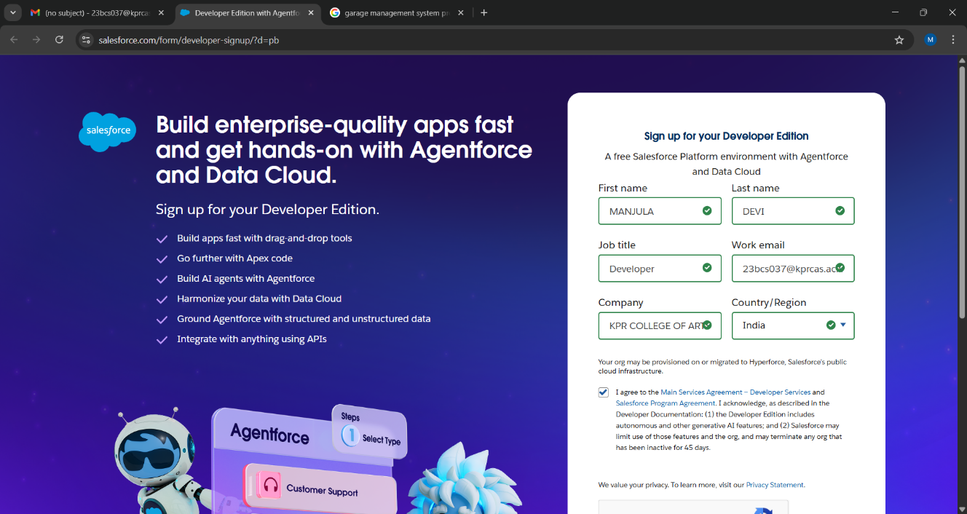

**3.2 Custom Object Creation**

Custom objects are the core data tables of the application. The following objects were created:

* Customer details
* Appointments
* Service Records
* Billing and Feedback
* **Customer Details:**

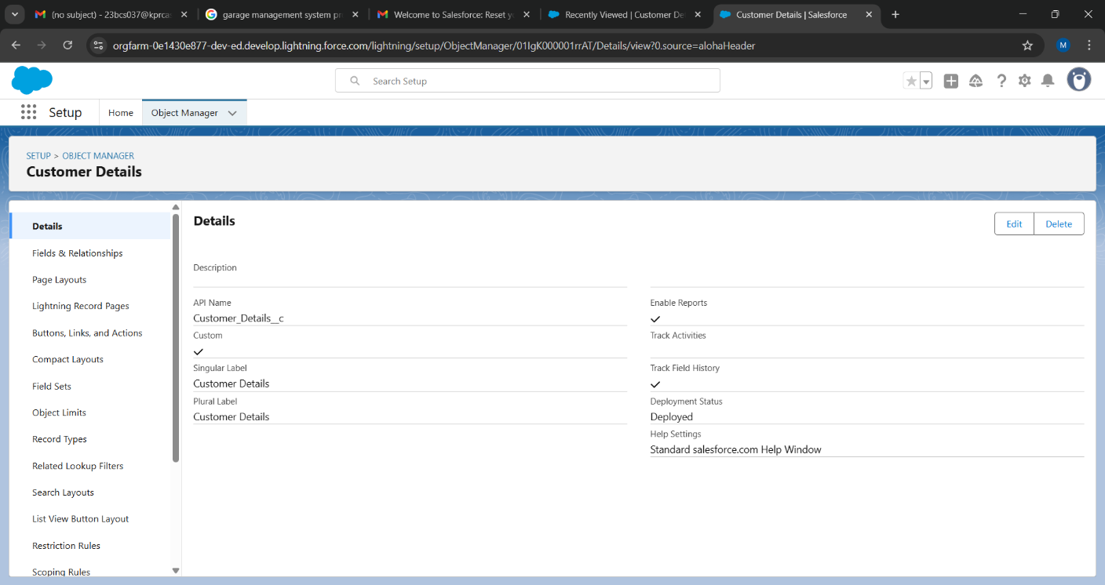

* **Appointment:**

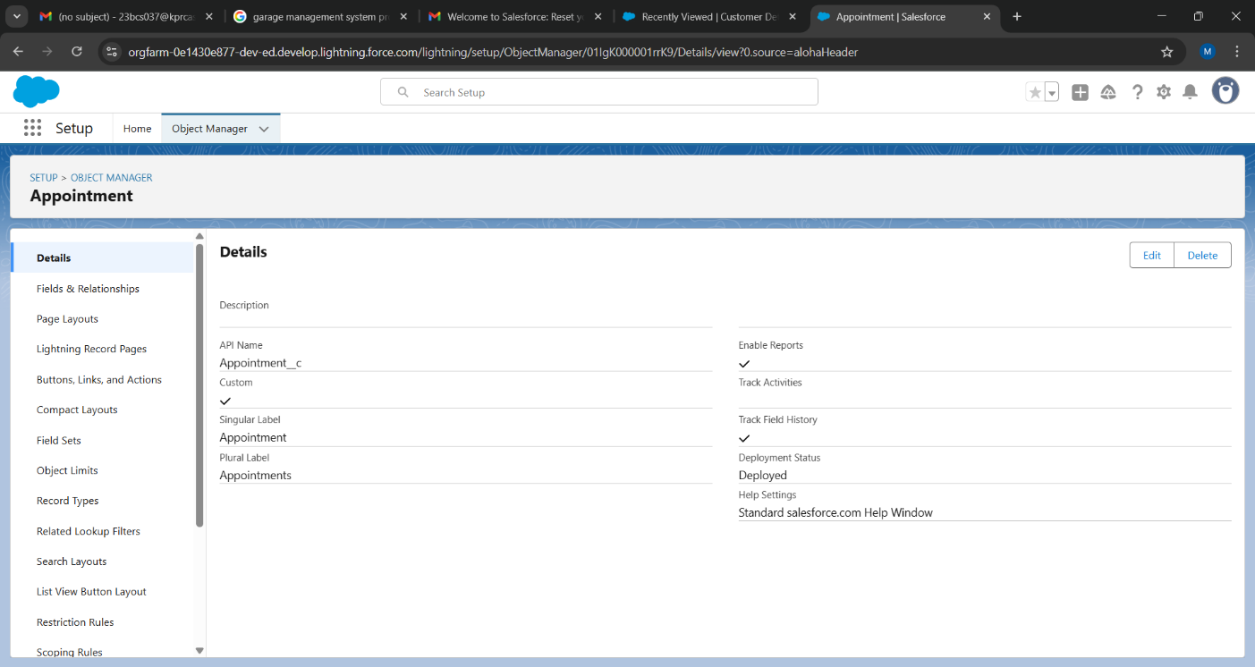

* **Service Records:**

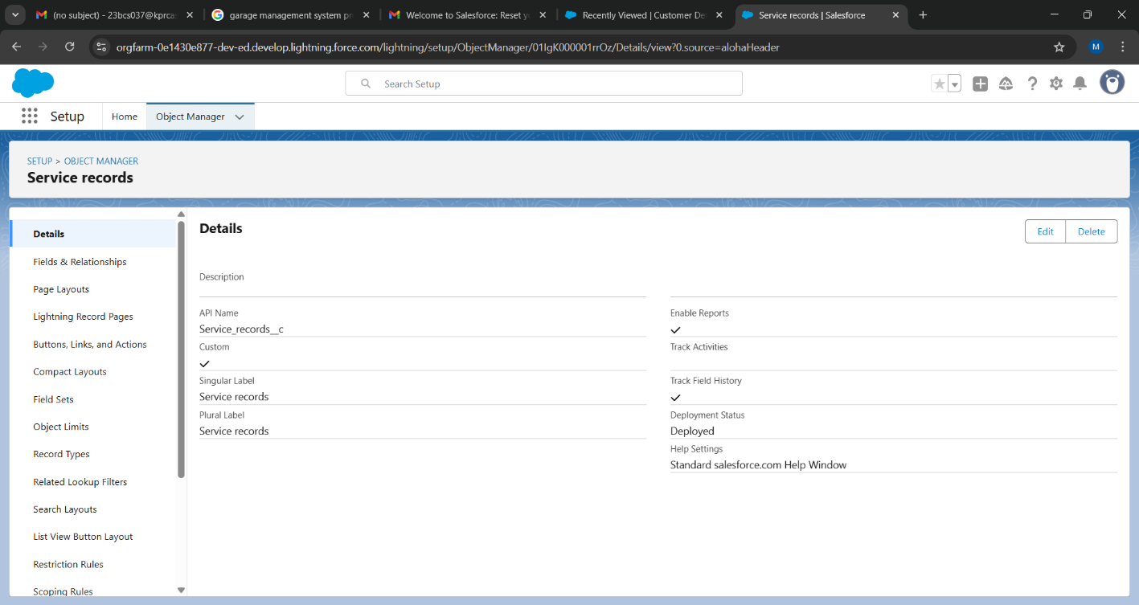

* **Billing and Feedback:**

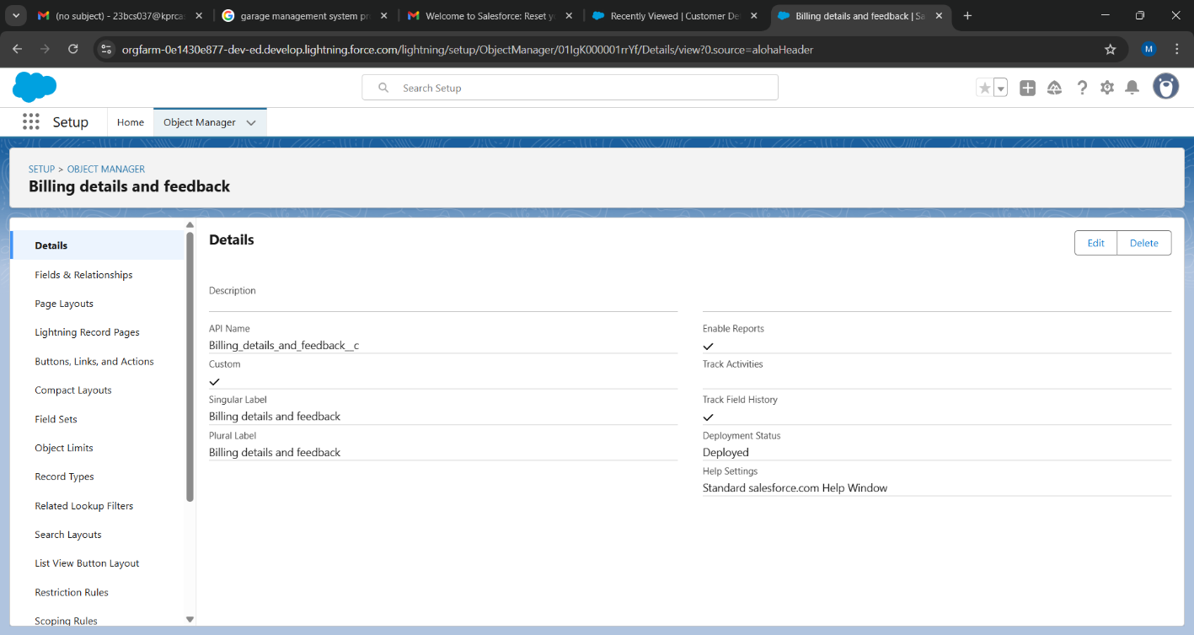

**3.3** **Custom Tab Creation**

A custom tab was created for each major object to allow users to easily view and create records.

* Tabs created for: Customer Details, Appointment, Service Records, Billing and Feedback.
* Each tab was configured with appropriate styles and icons for easy identification.

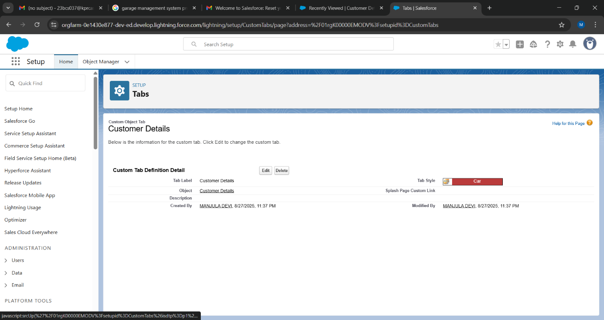

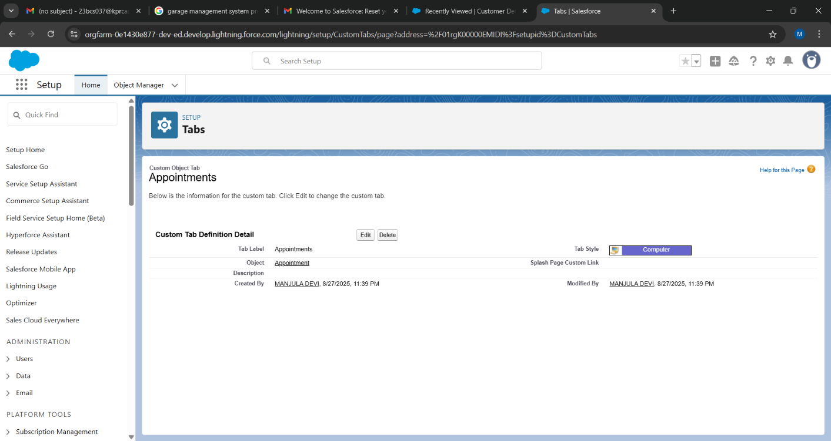

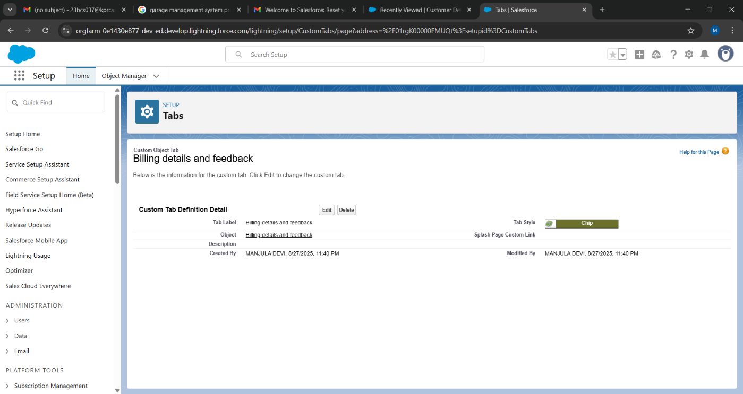

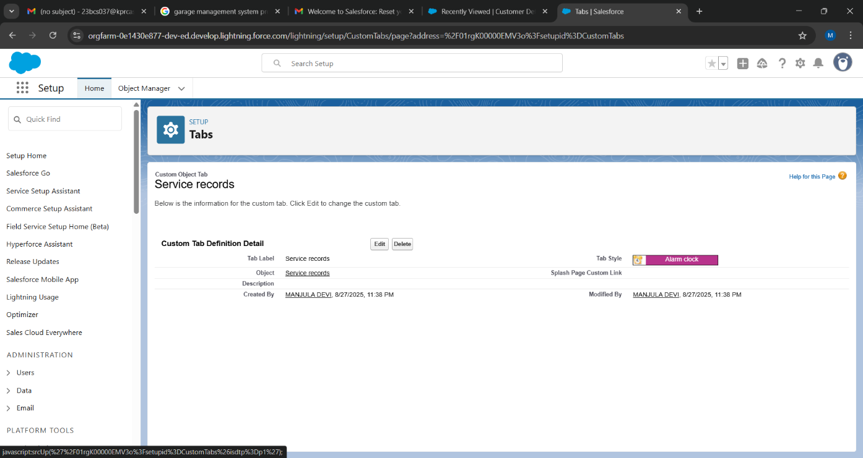

**3.4 Lightning Application Builder**

A custom Lightning App named **"Garage Management System Application"** was assembled.

Developed Lightning App with relevant tabs

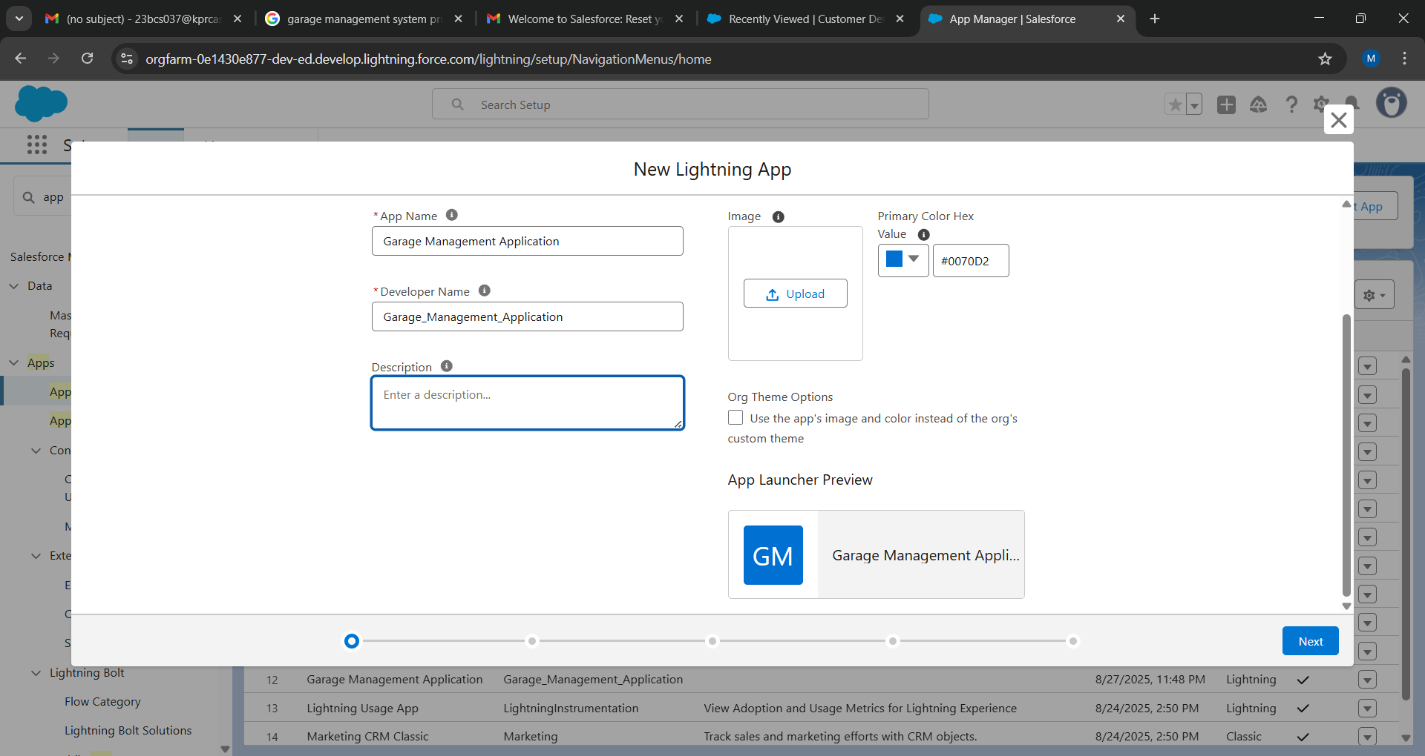

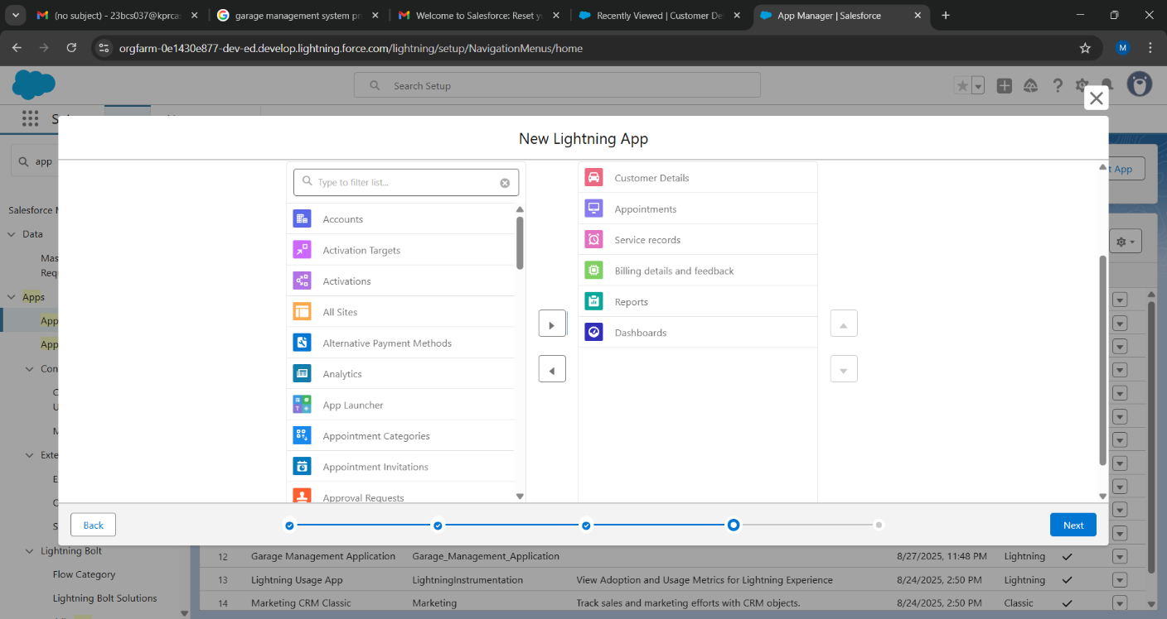

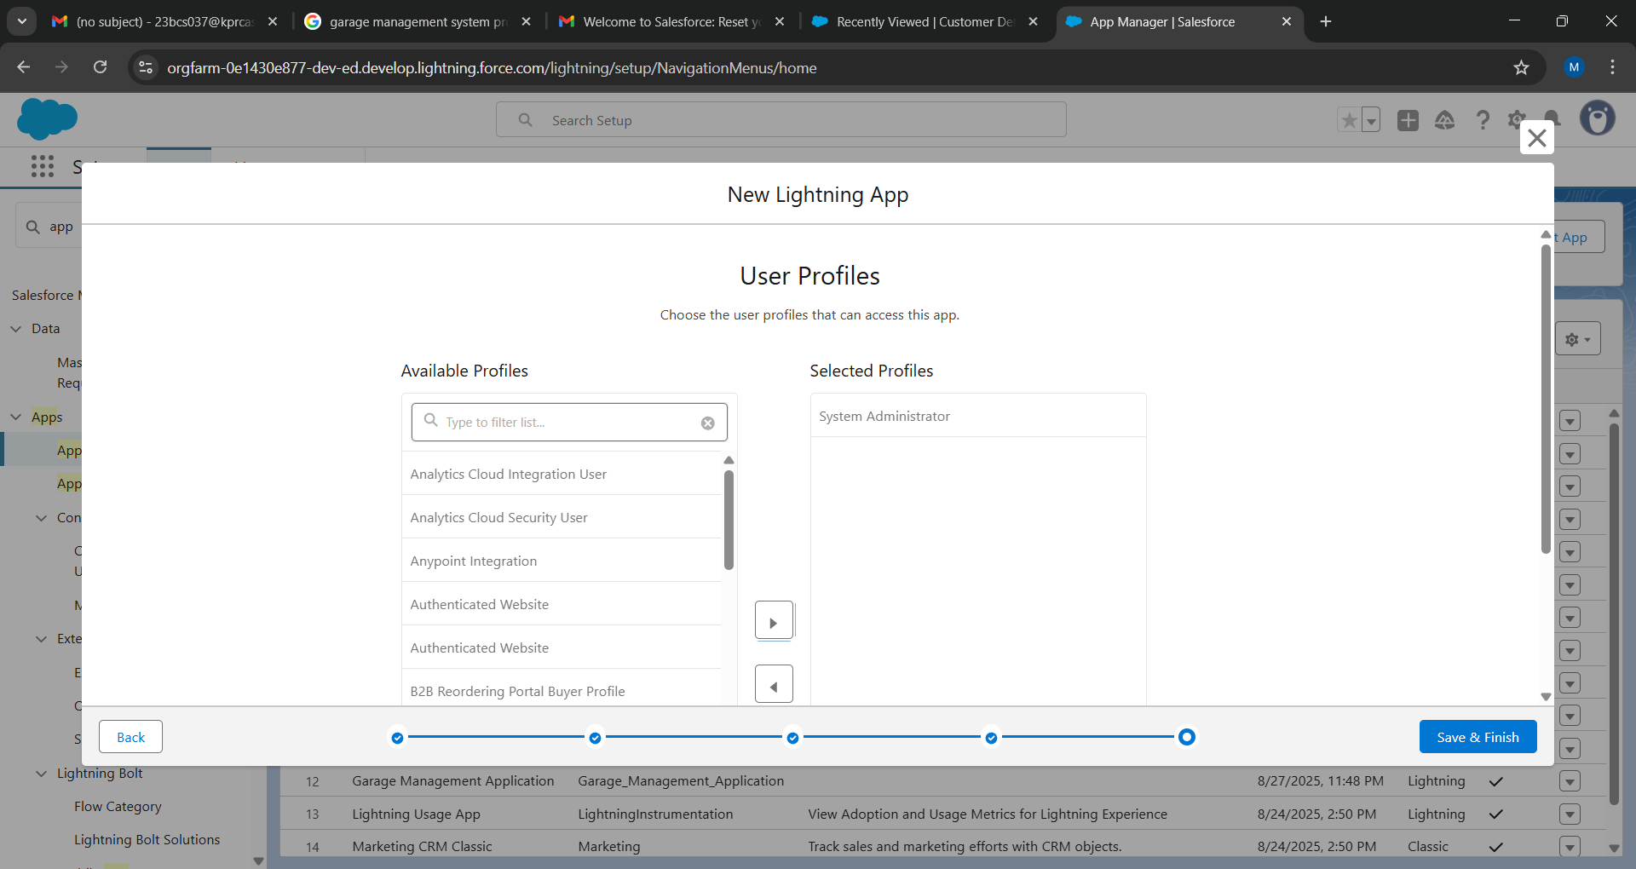

**3.5 Field Creation for Objects**

Various field types were added to objects to capture specific data:

* **Customer Details Object:**

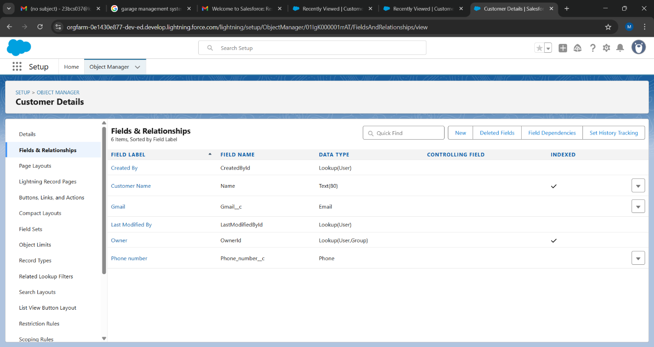

* **Appointment Object:**

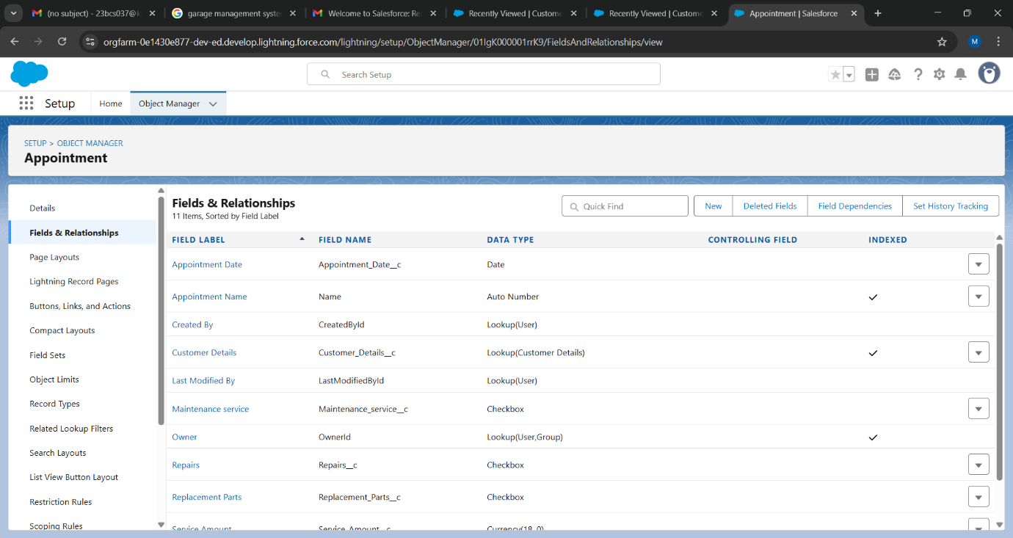

* **Service Records Object:**

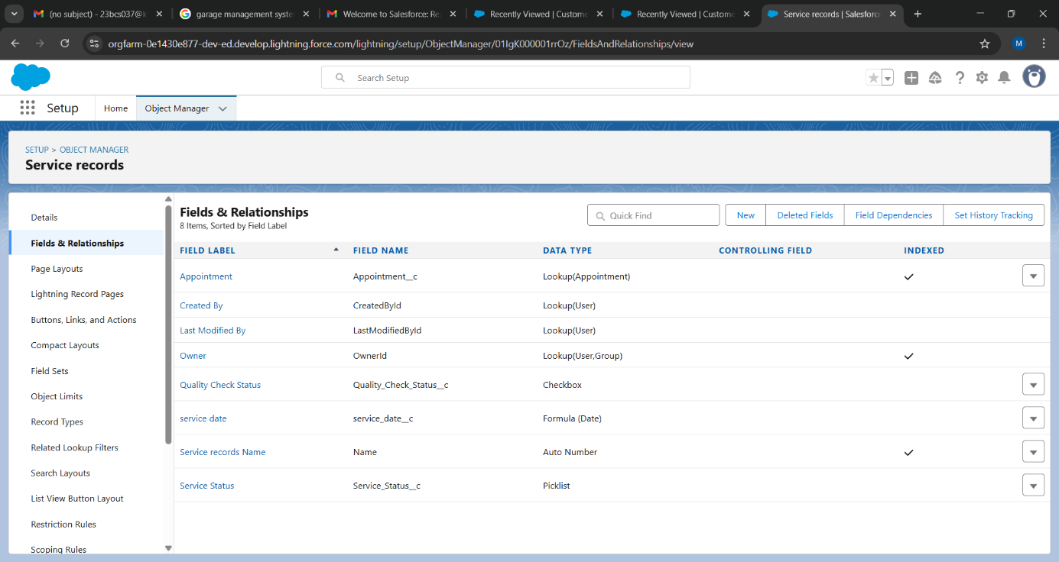

* **Billing and Feedback Object:**

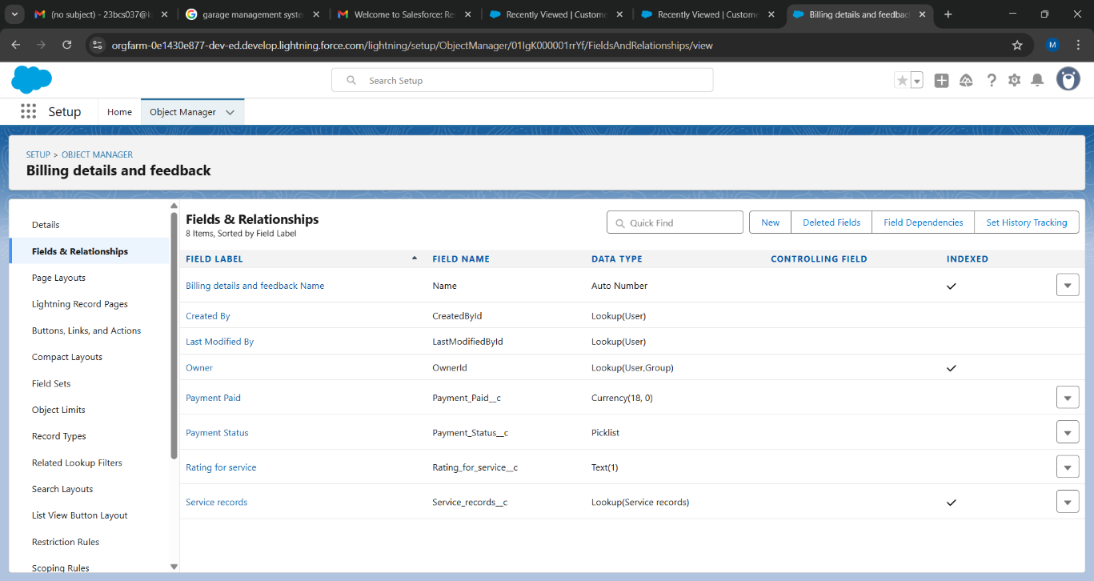

**3.6 Validation Rules**

Rules were implemented to ensure data quality:

* **Appointment Object (Invalid Vehicle Plate):**

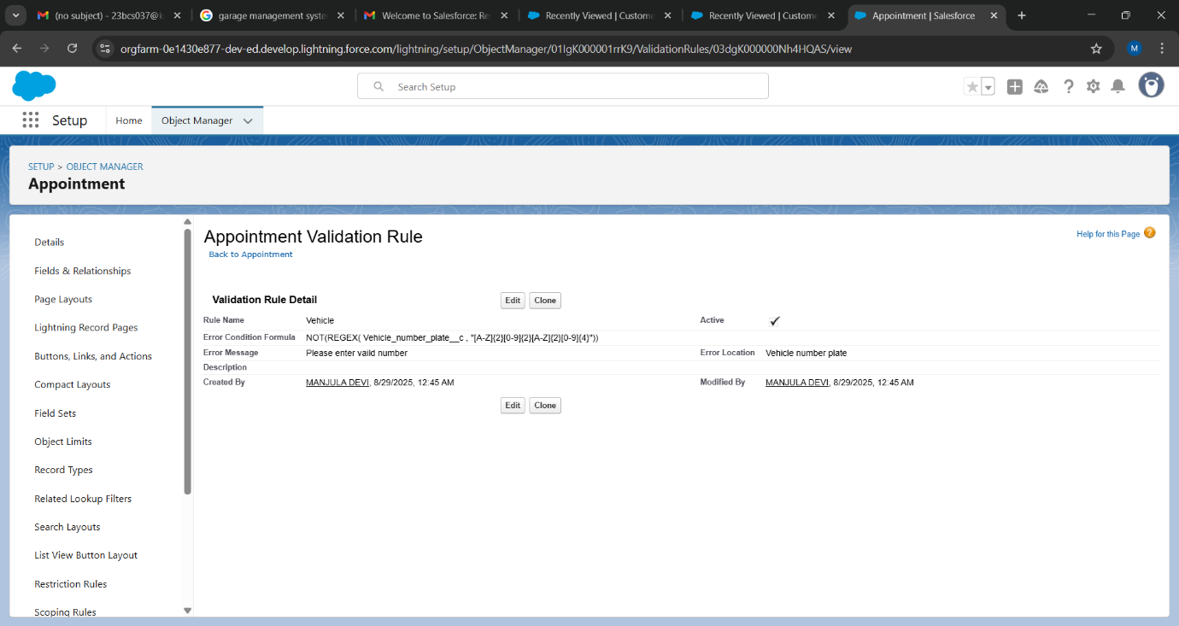

* **Billing and Feedback Object (Invalid Rating):**

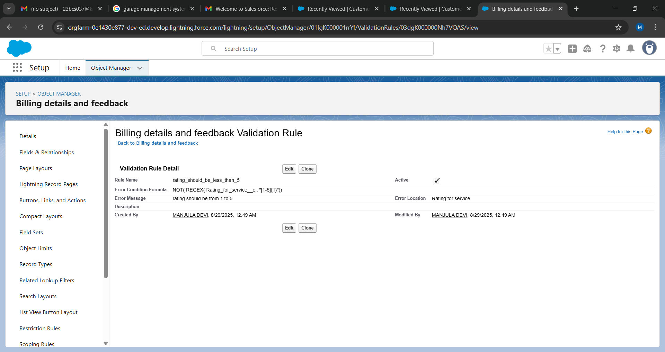

**3.7 Duplicate Management Rules**

A matching rule was created to identify duplicate Customer Details records based on exact matches of Customer Name and Email. A duplicate rule was then activated to block users from creating these duplicates, prompting them to review the existing record instead.

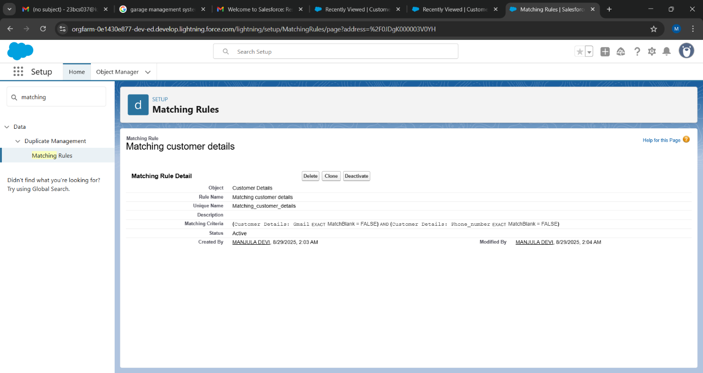

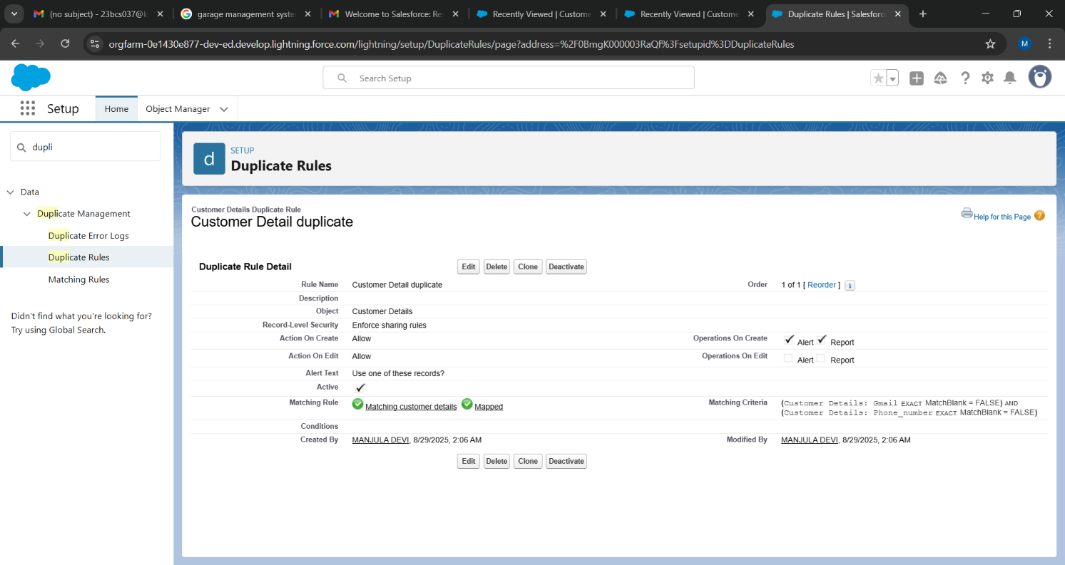

**3.8 User Management: Profiles, Roles, and Hierarchy**

* **Profiles:** Two key profiles were configured.
* **Manager Profile:** Granted full Read, Create, Edit, Delete, View All, and Modify All permissions on all custom objects.

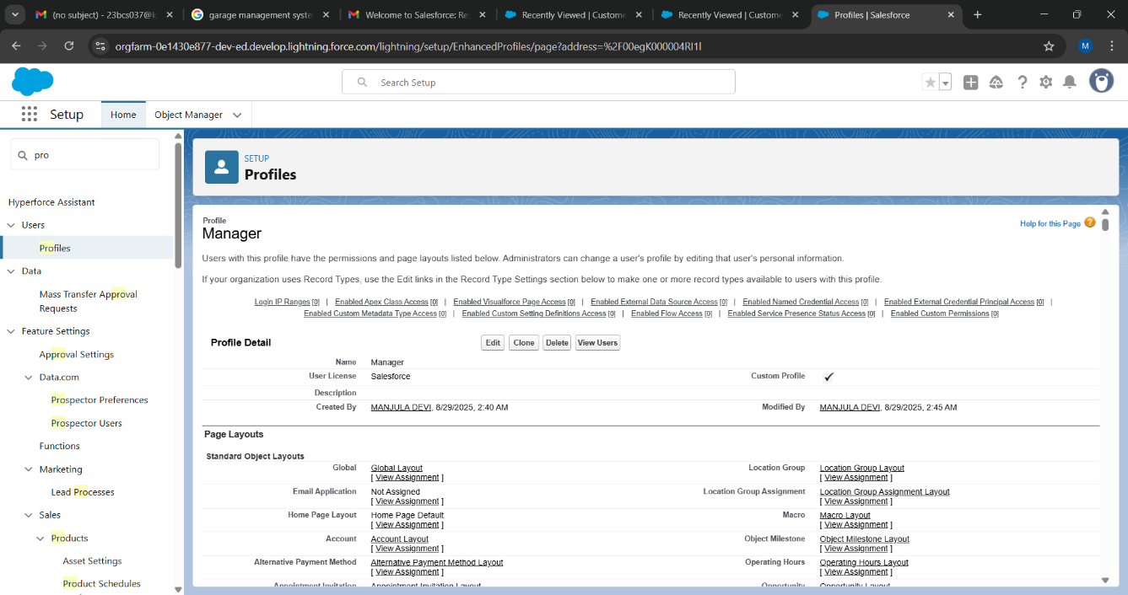

* **Salesperson Profile:** Granted Read, Create, and Edit permissions on Service Records but only Read access on other objects like Customer Details and Billing and Feedback.

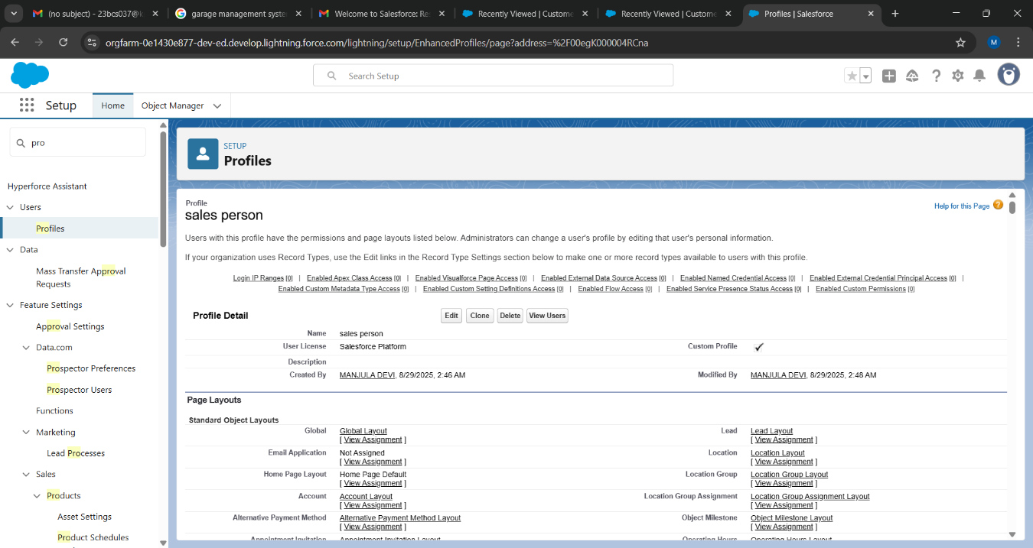

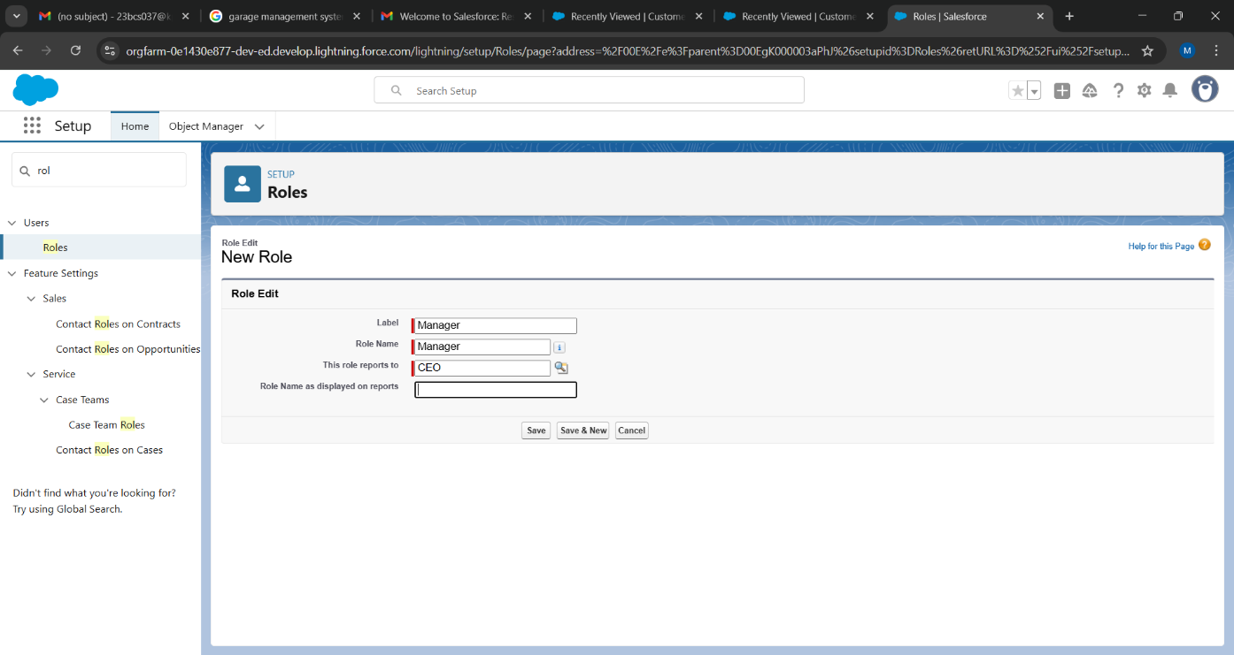

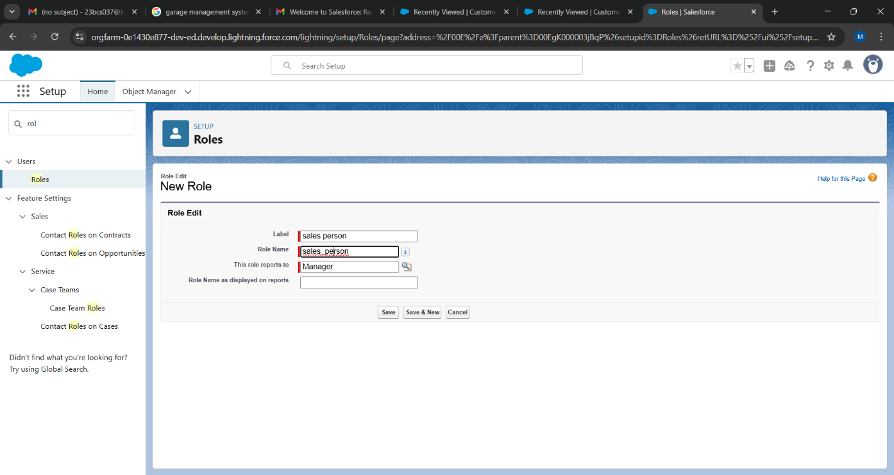

* **Role Hierarchy:** A hierarchy was established to control record visibility.

CEO (Top Level)-> Manager-> -> Salesperson

**3.9 Creating Users**

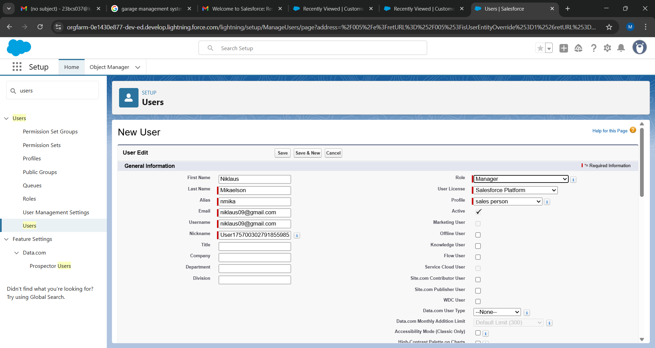

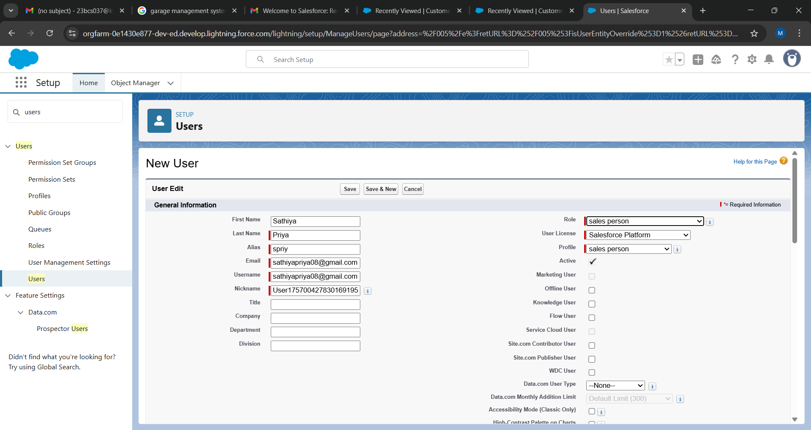

**\**

**3.10 Public Groups and Organization-Wide Defaults**

* A **Public Group** named "Sales Team" was created, and all user accounts with the Salesperson profile were added as members.

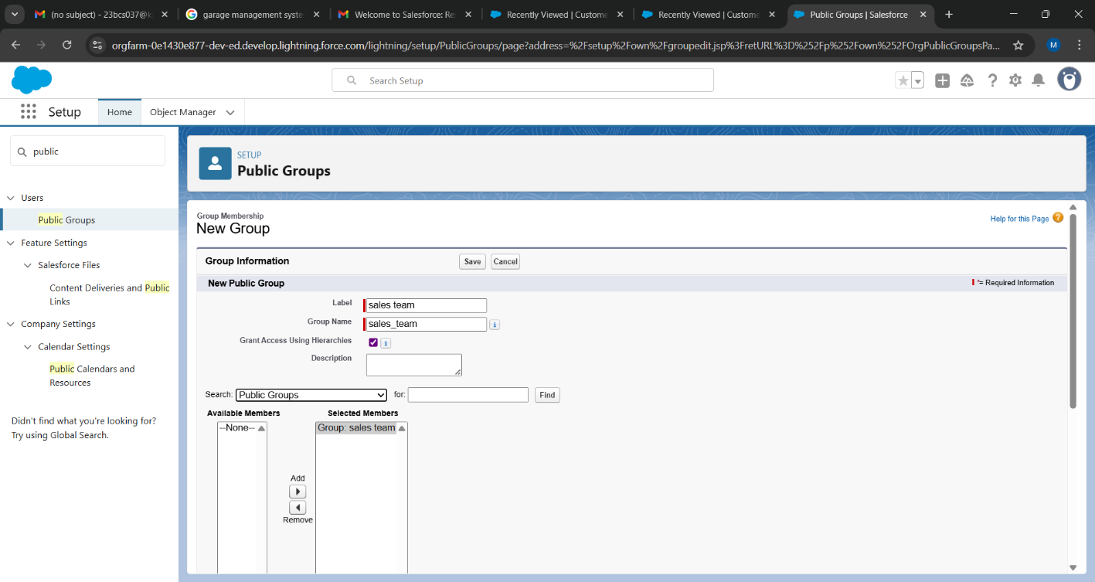

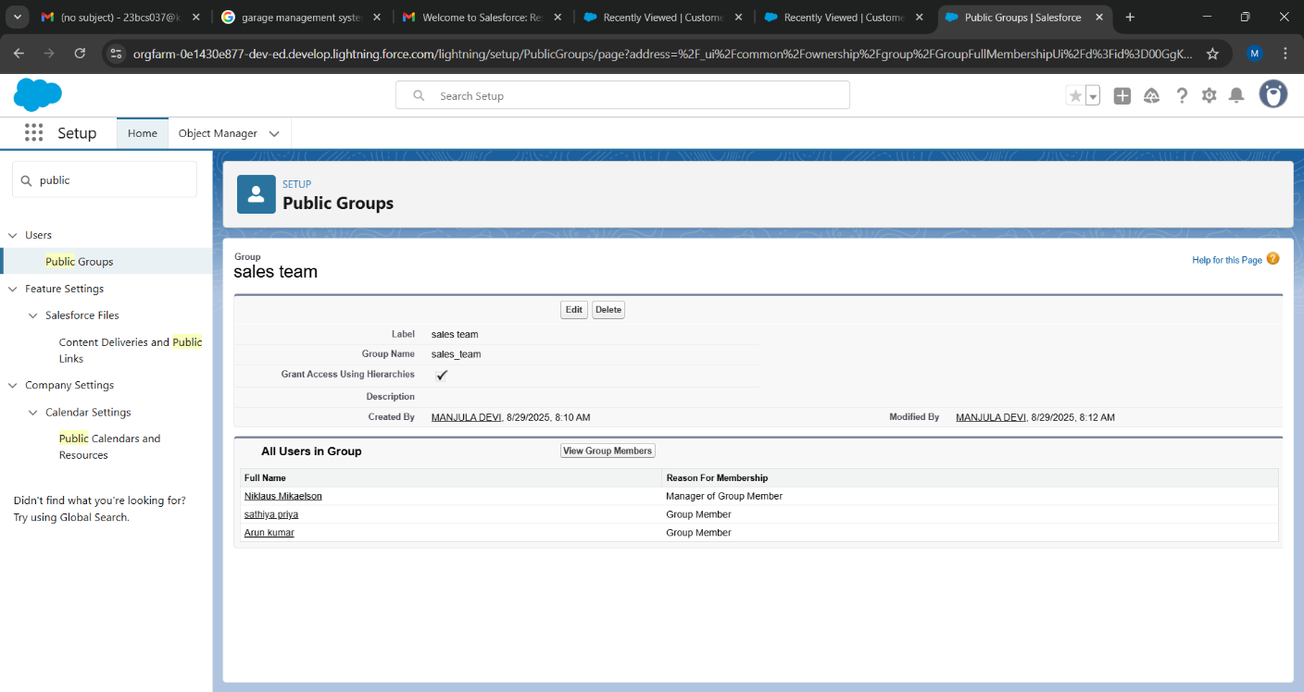

**3.11 Creating Sharing Settings**

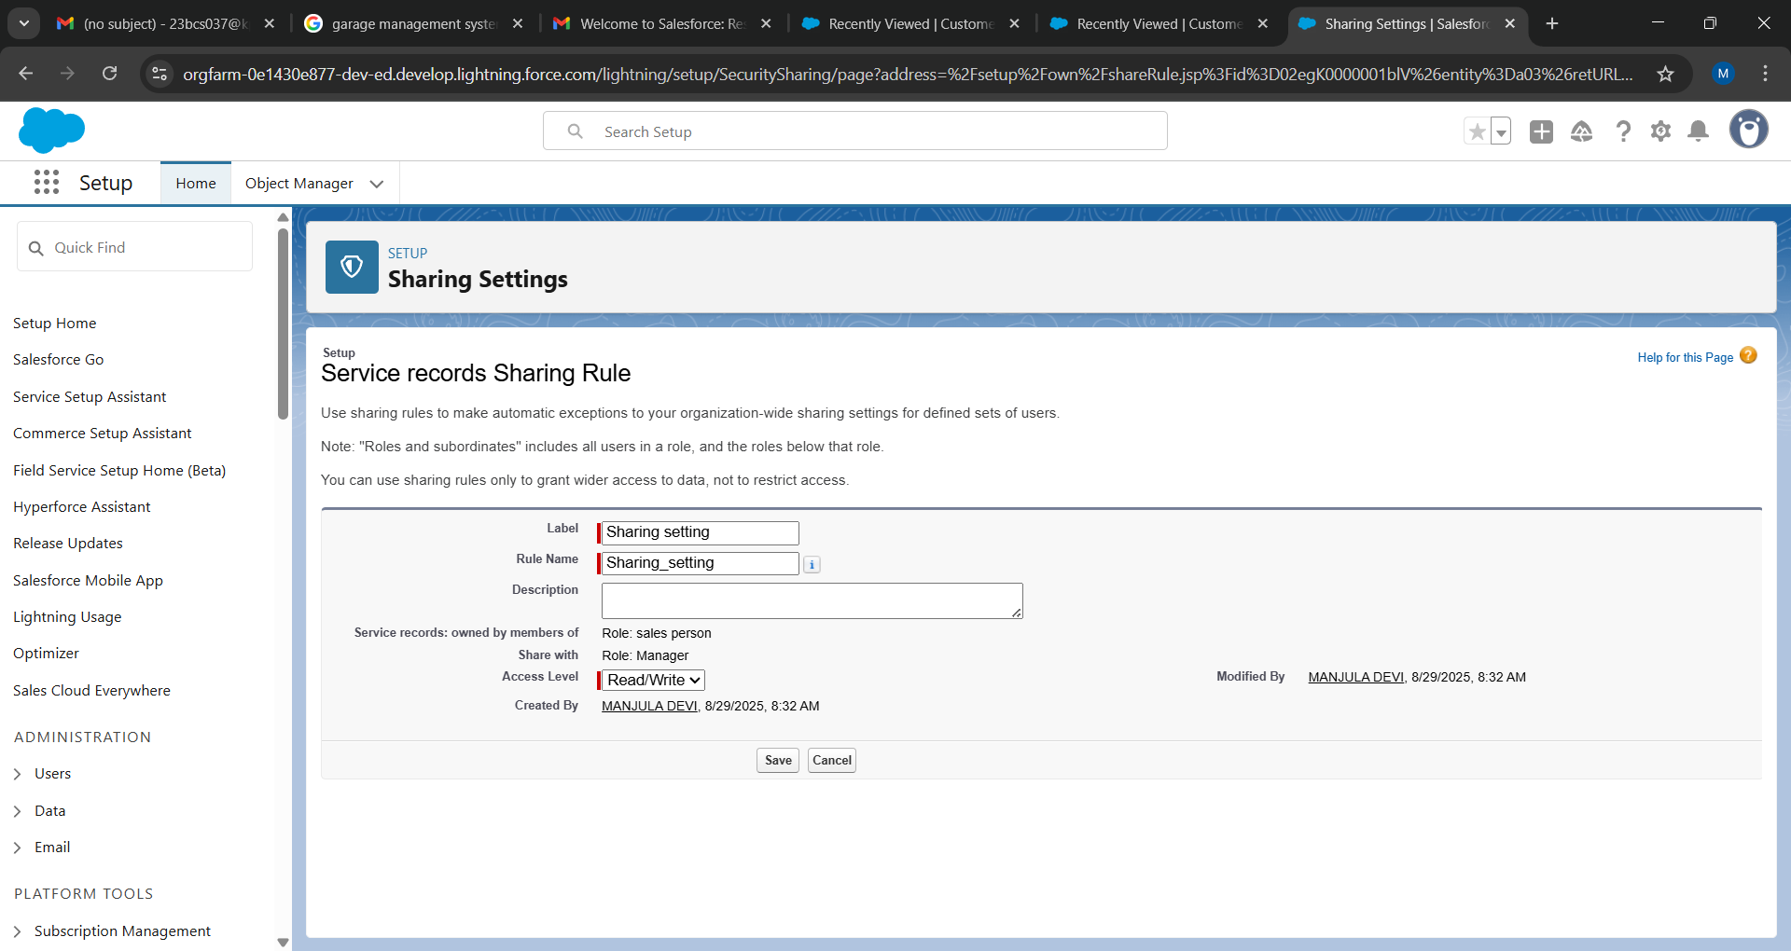

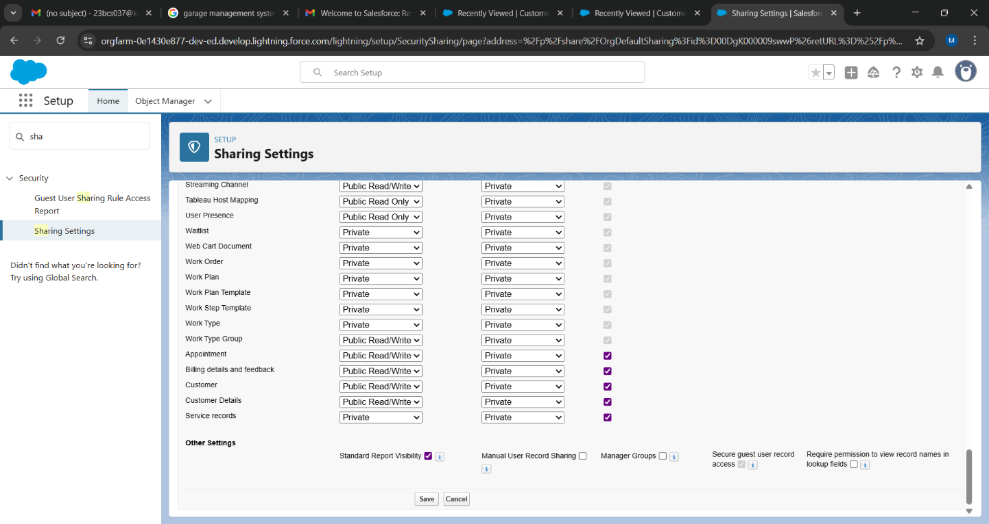

**3.12 Automation: Flows**

A **Record-Triggered Flow** was built on the Billing and Feedback object.

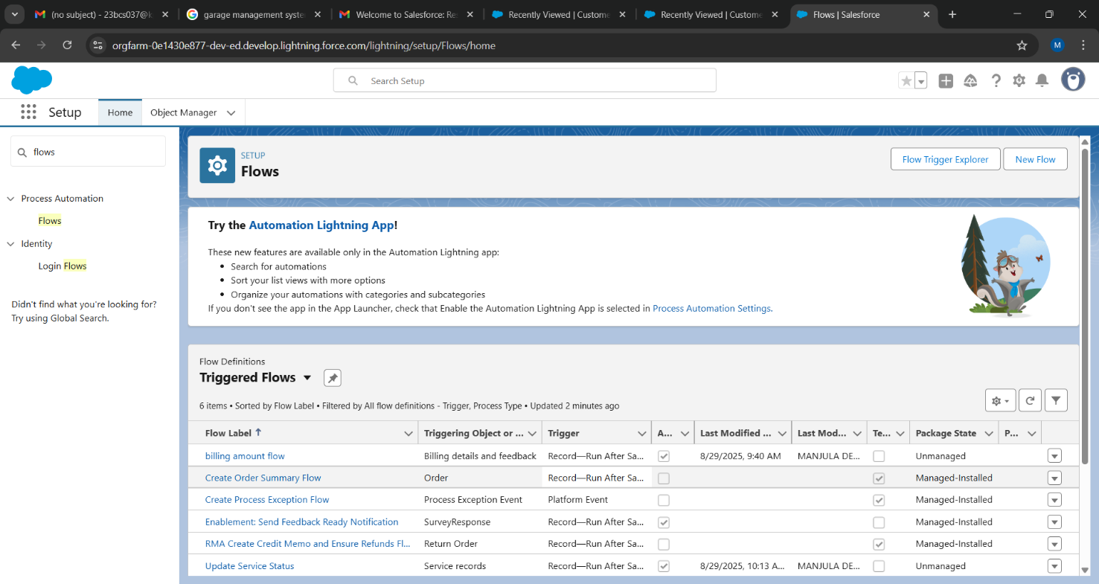

**3.13 Create Apex Class**

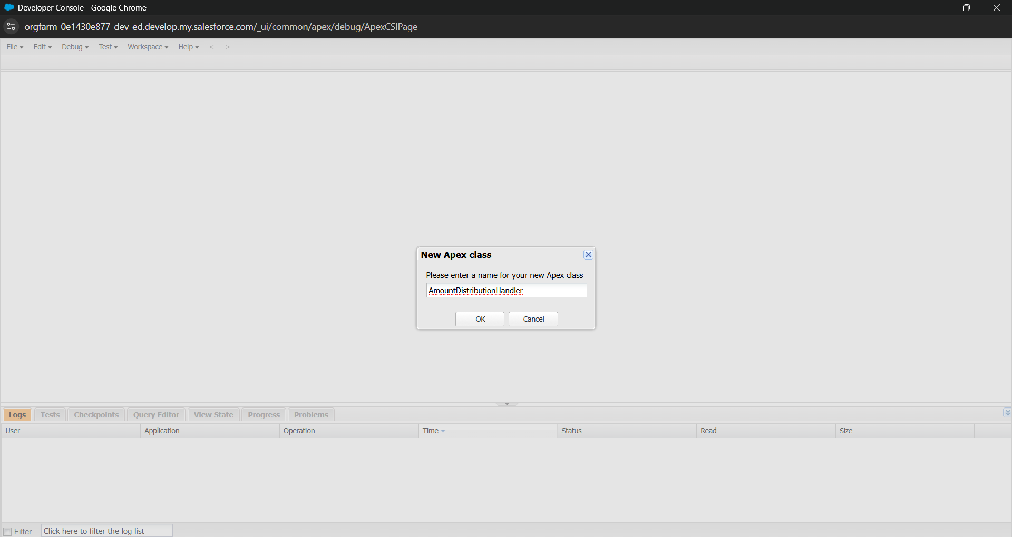

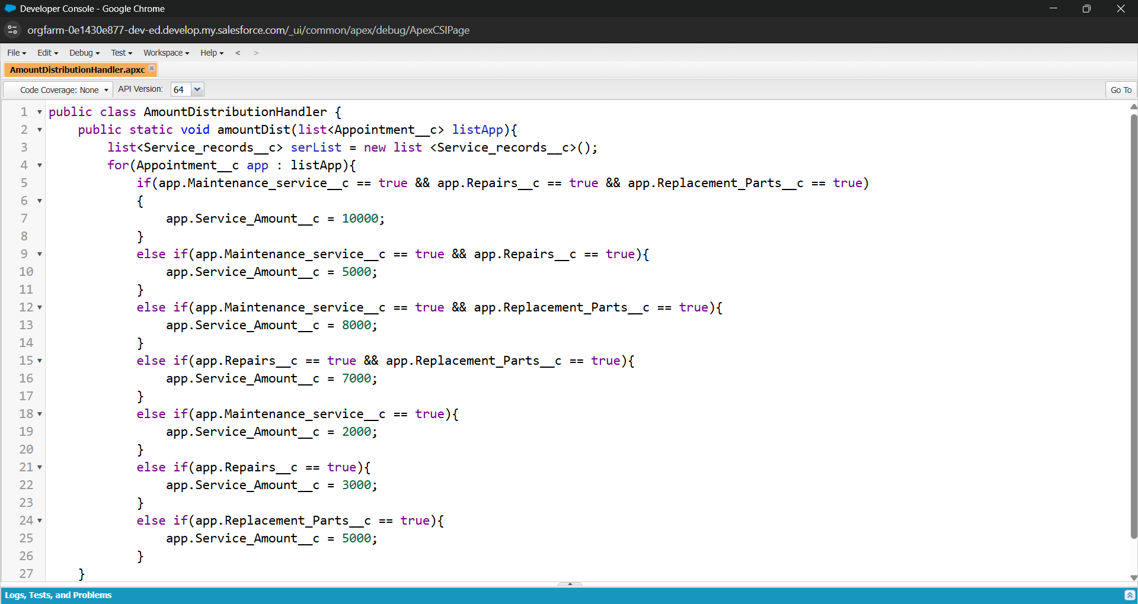

**3.14 Create Apex Triggers**

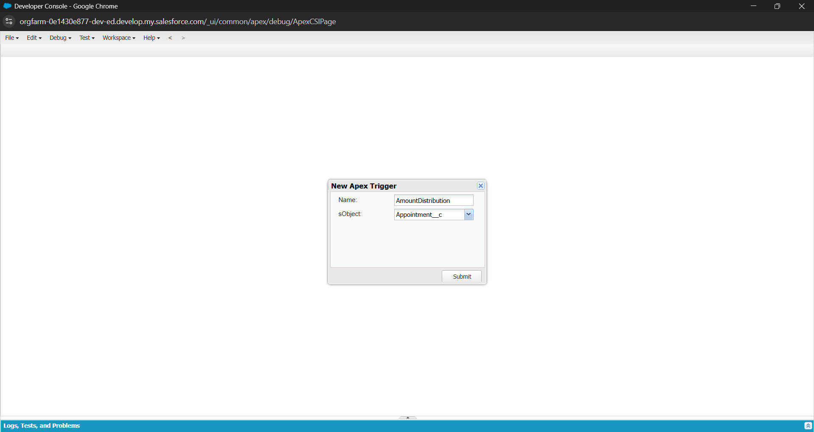

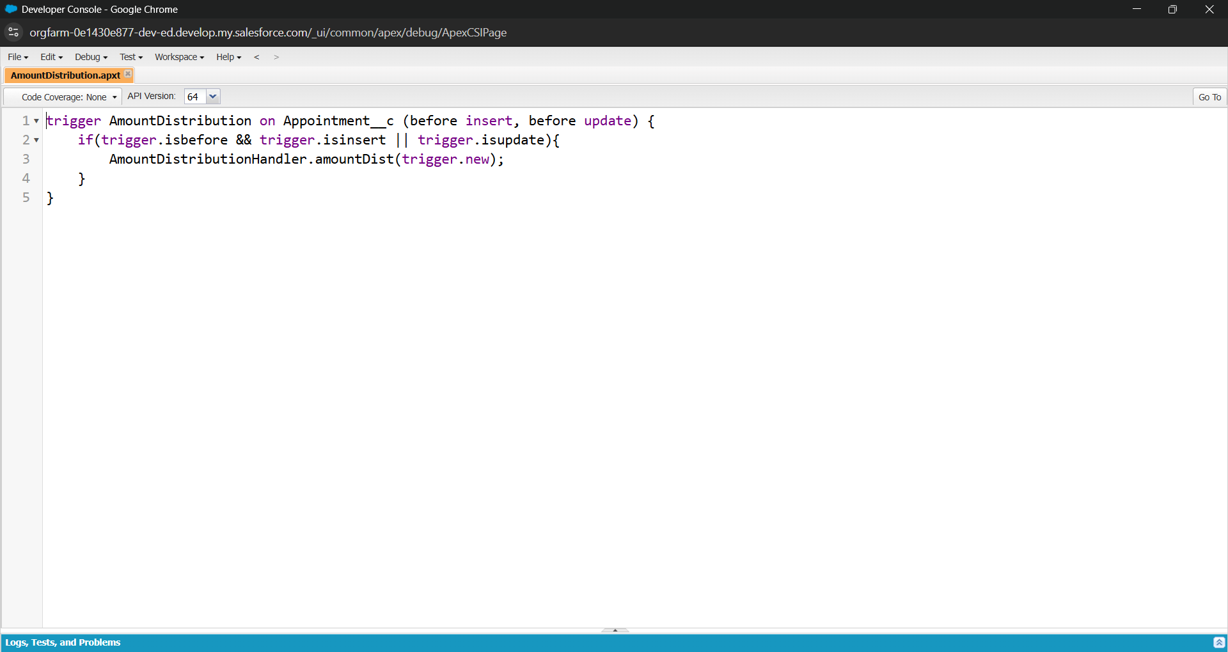

**3.15 Reporting**

A custom report folder was created to organize all reports related to the application.

* **Report Example:** "Service Information Report"

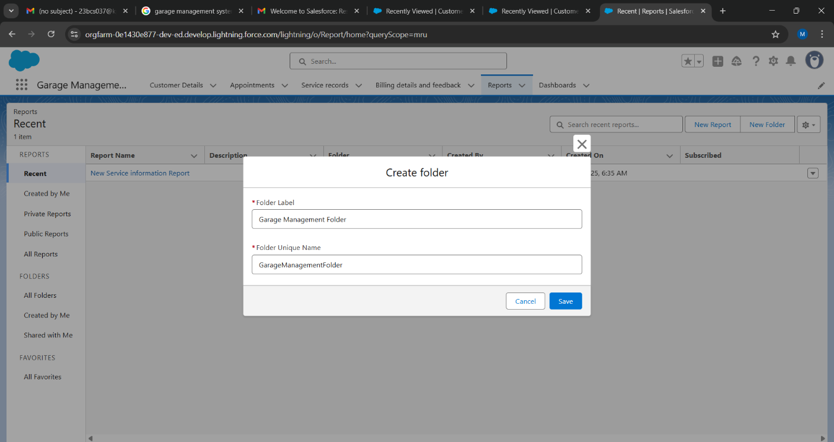

**Sharing a report folder:**

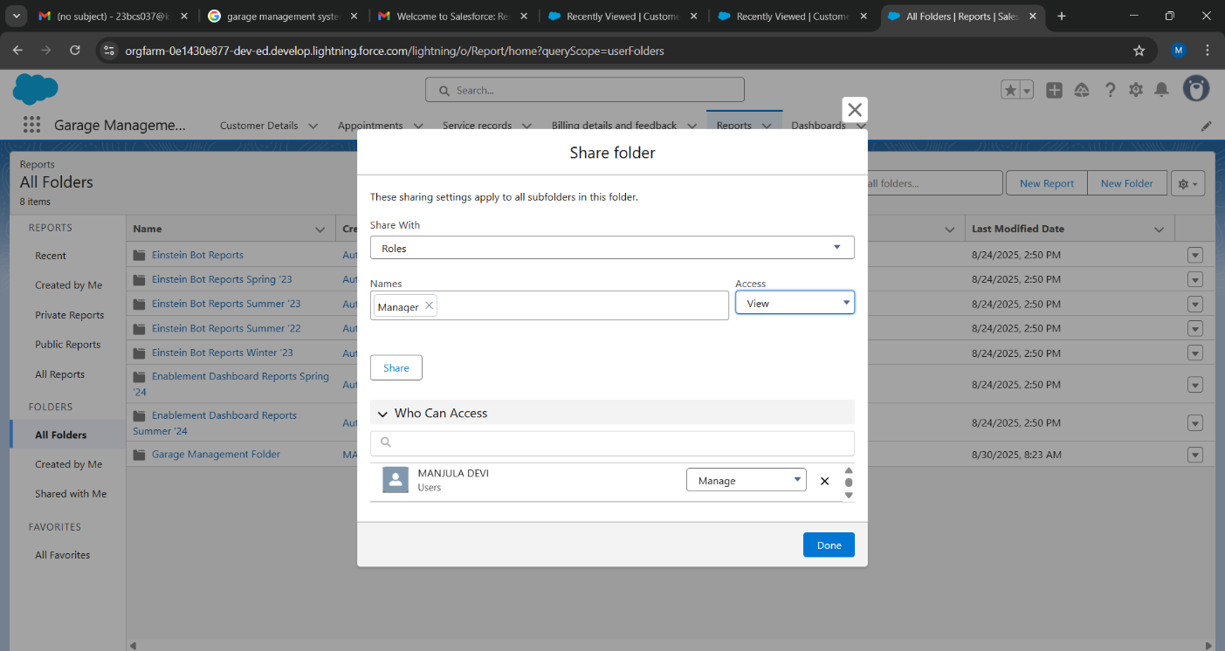

**Create Report Type**

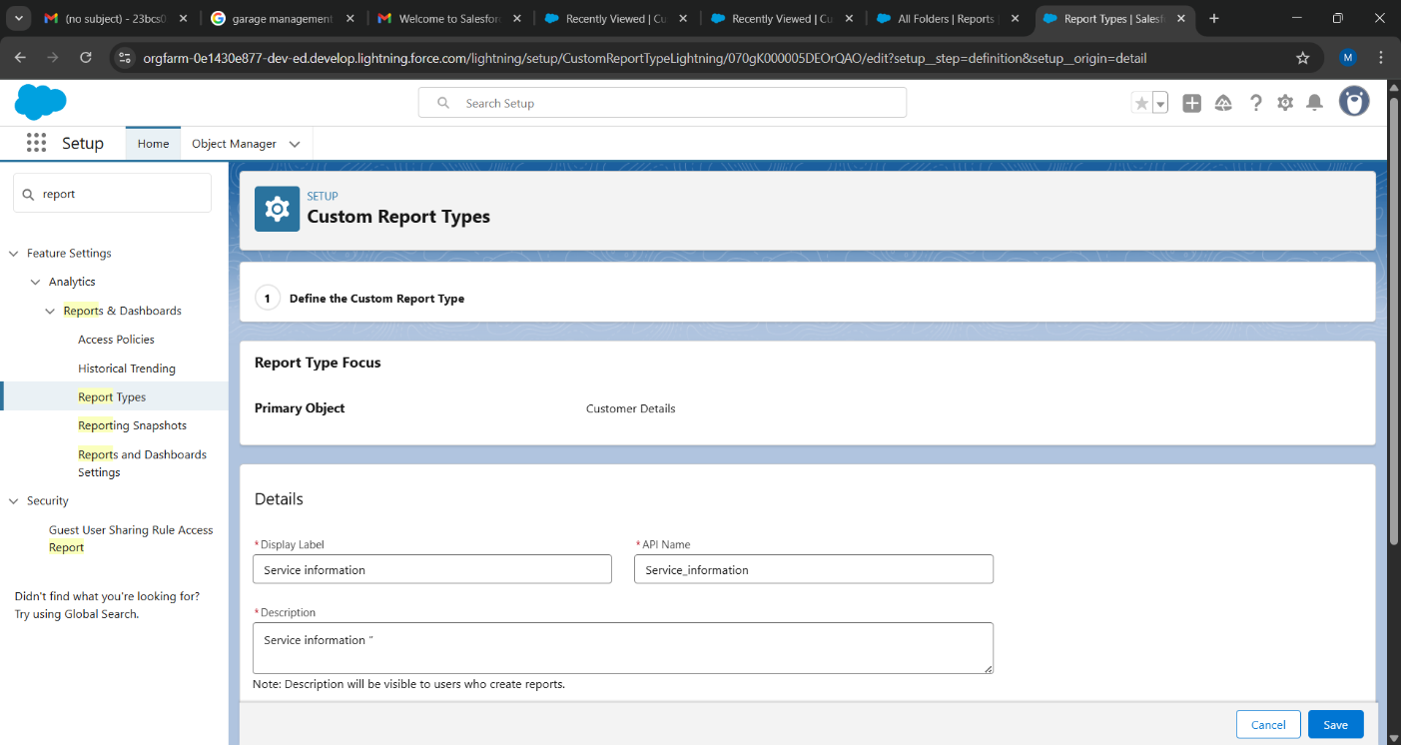

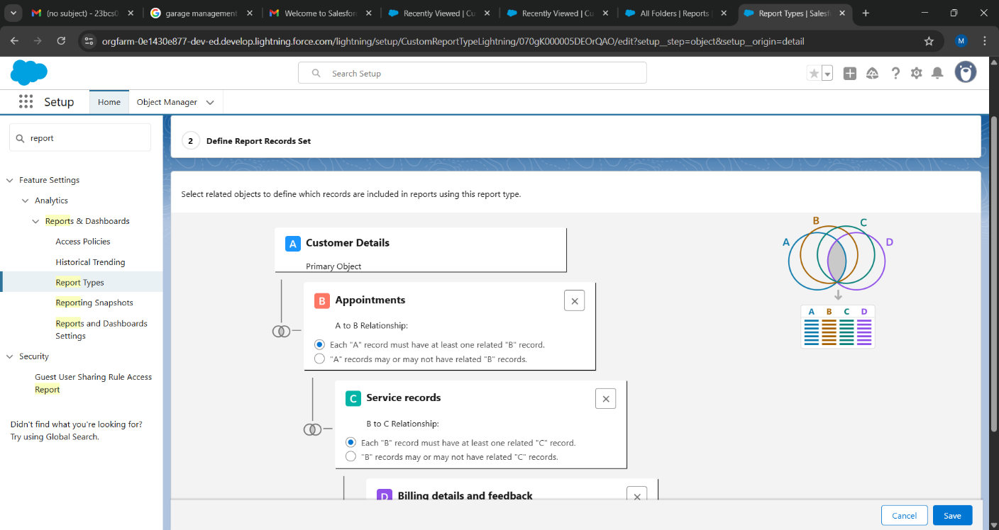

**Report**

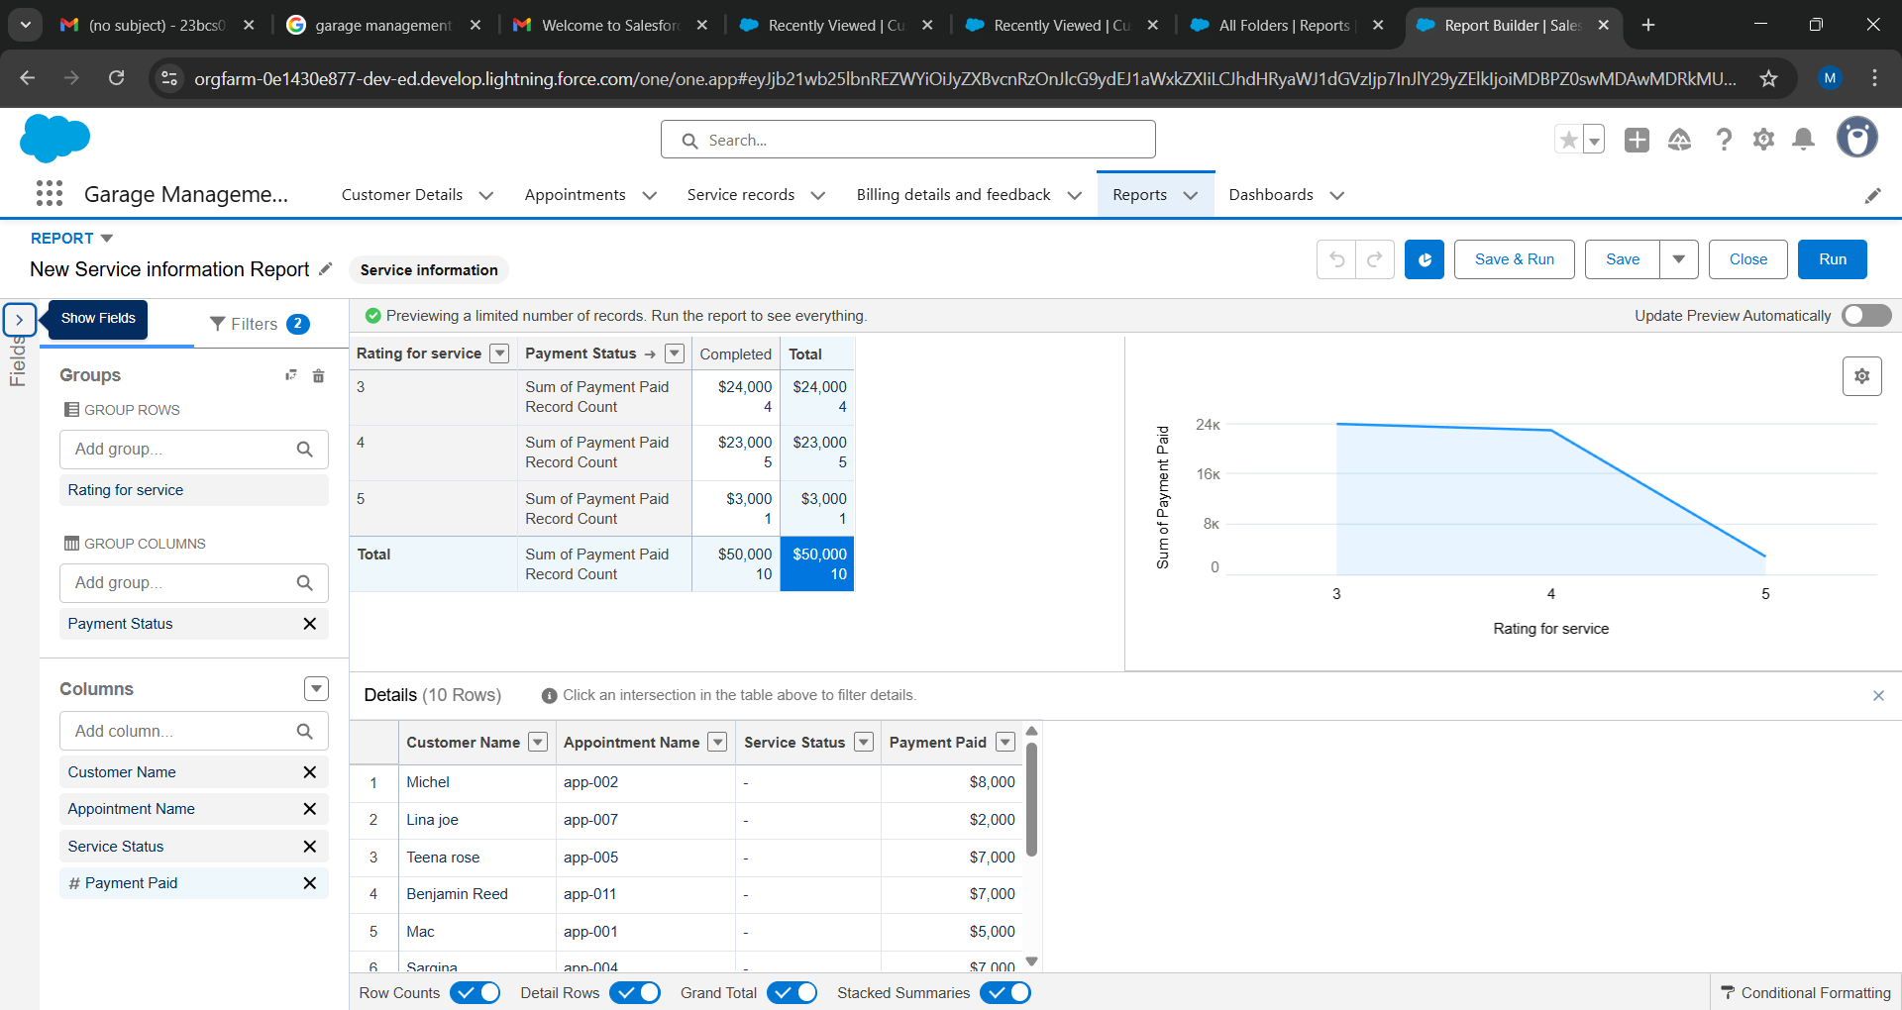

**3.16 Dashboards**

A dashboard was created to visualize the report data.

**Create Dashboard Folder**

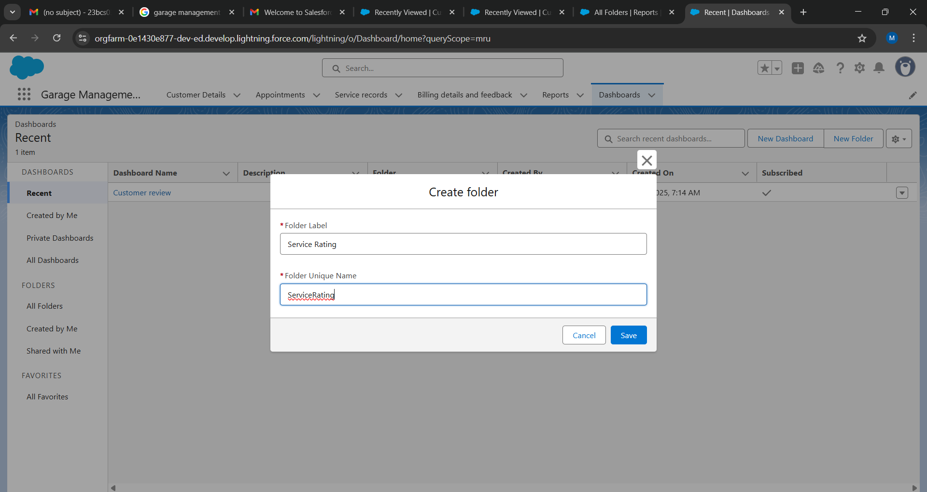

**Create Dashboard**

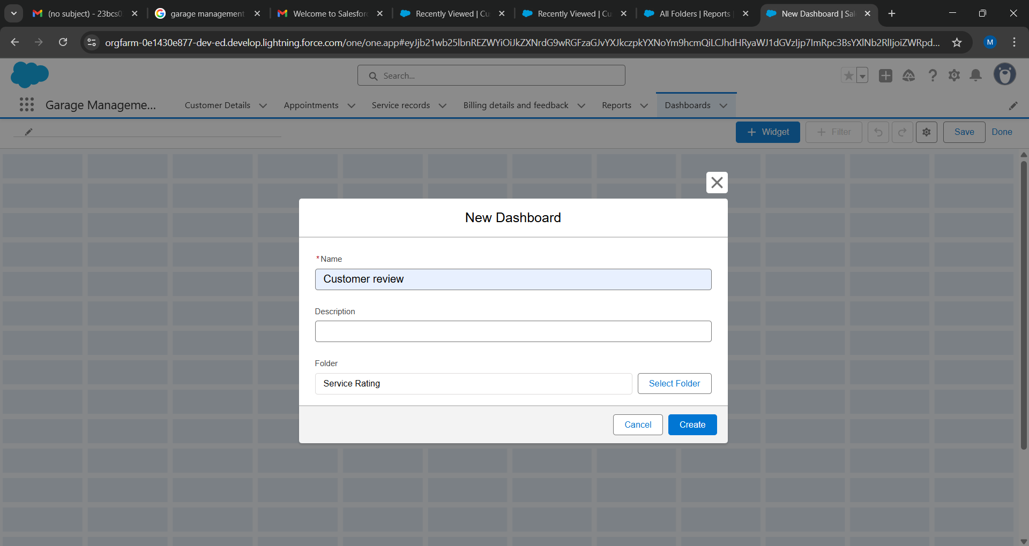

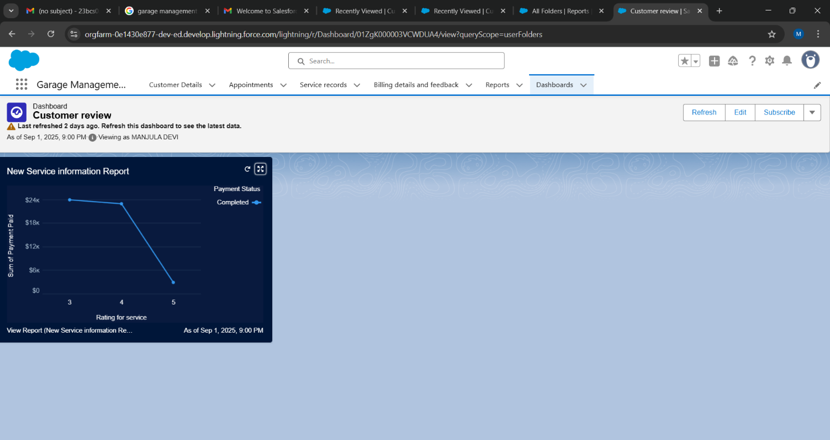

**4. Application Walkthrough**

**4.1 Managing Customer Details**

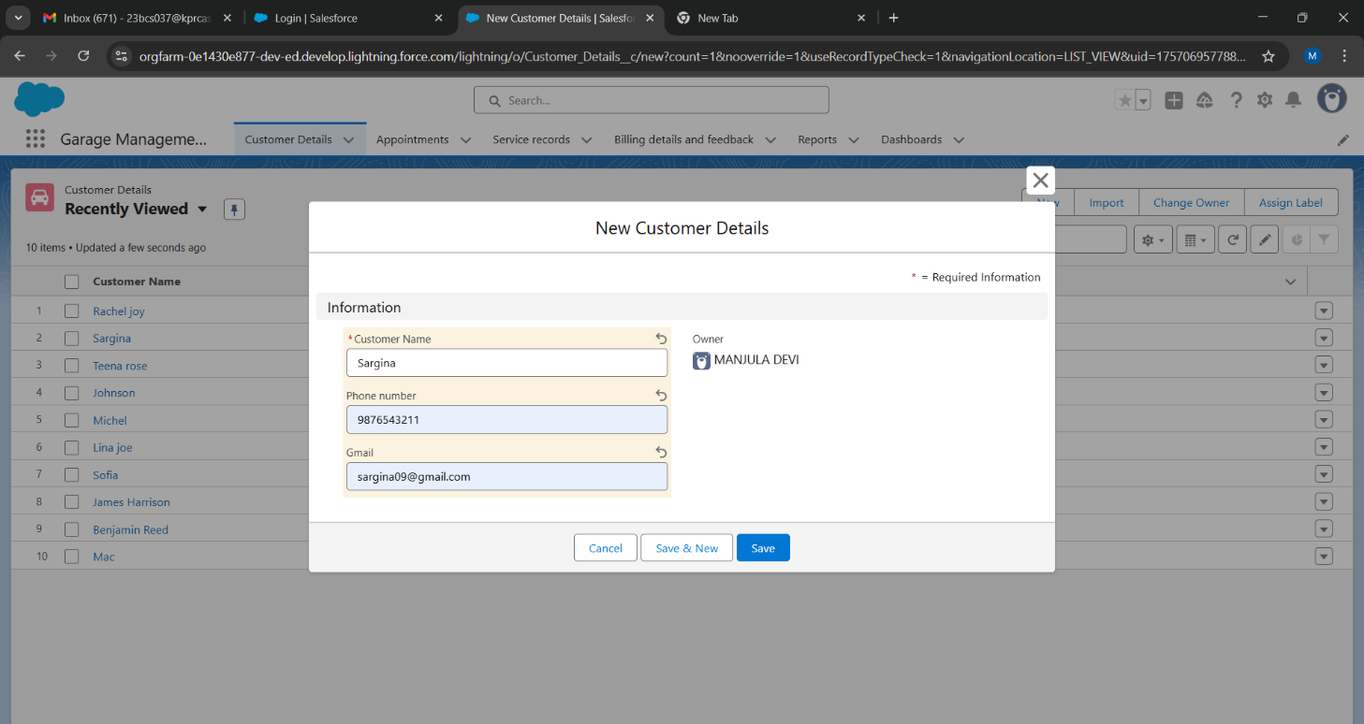

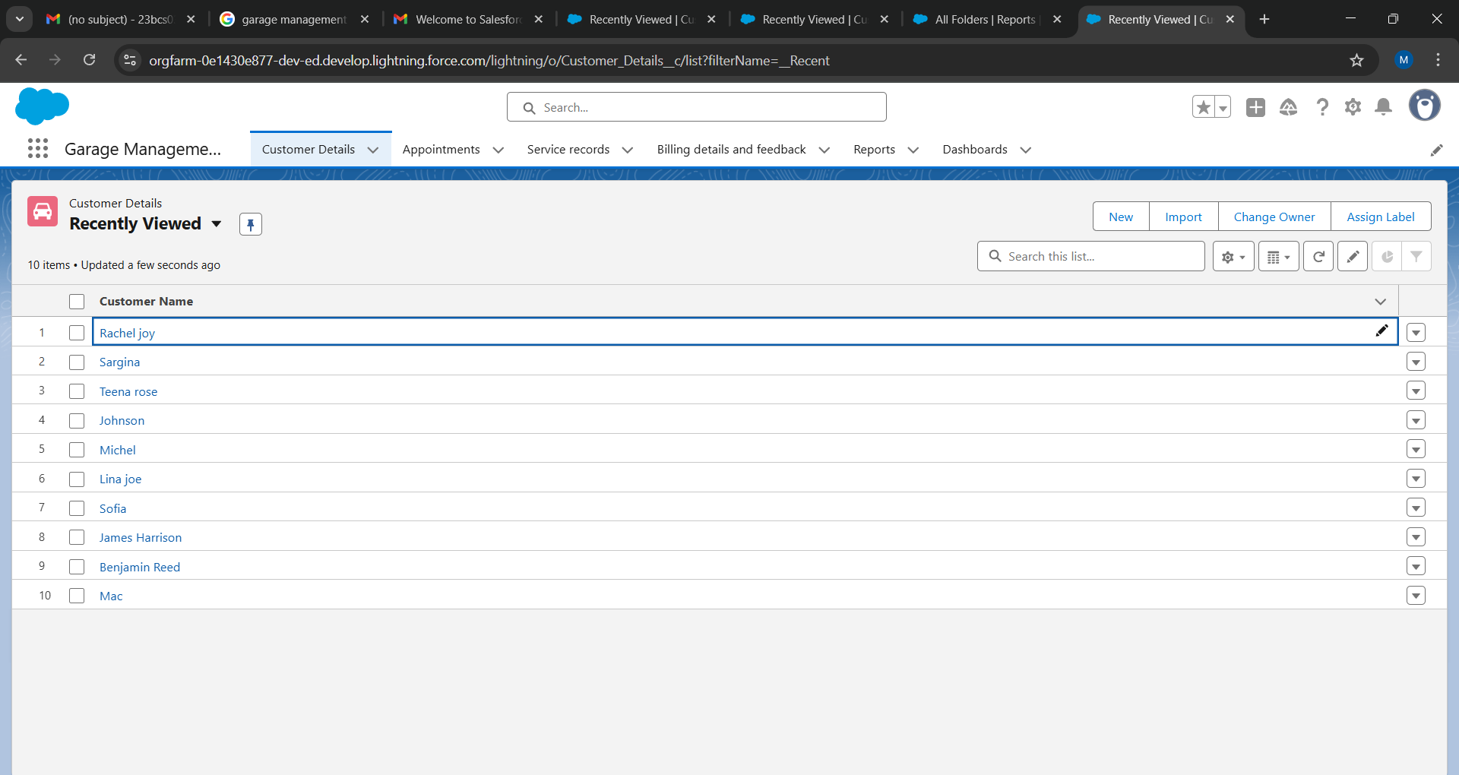

**4.2 Scheduling Appointments**

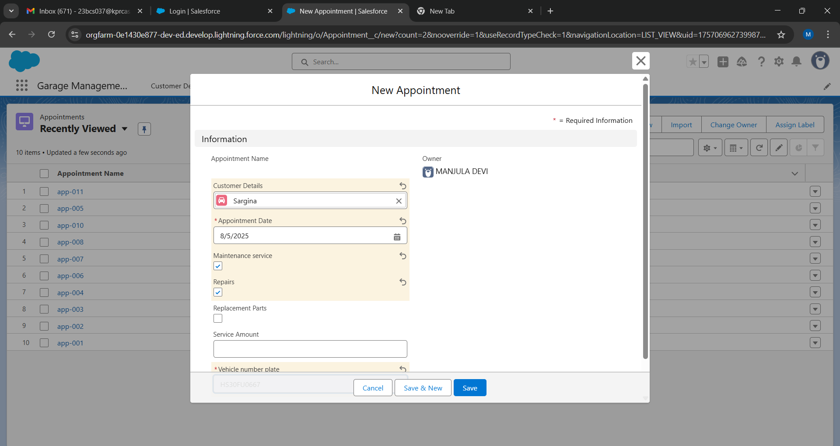

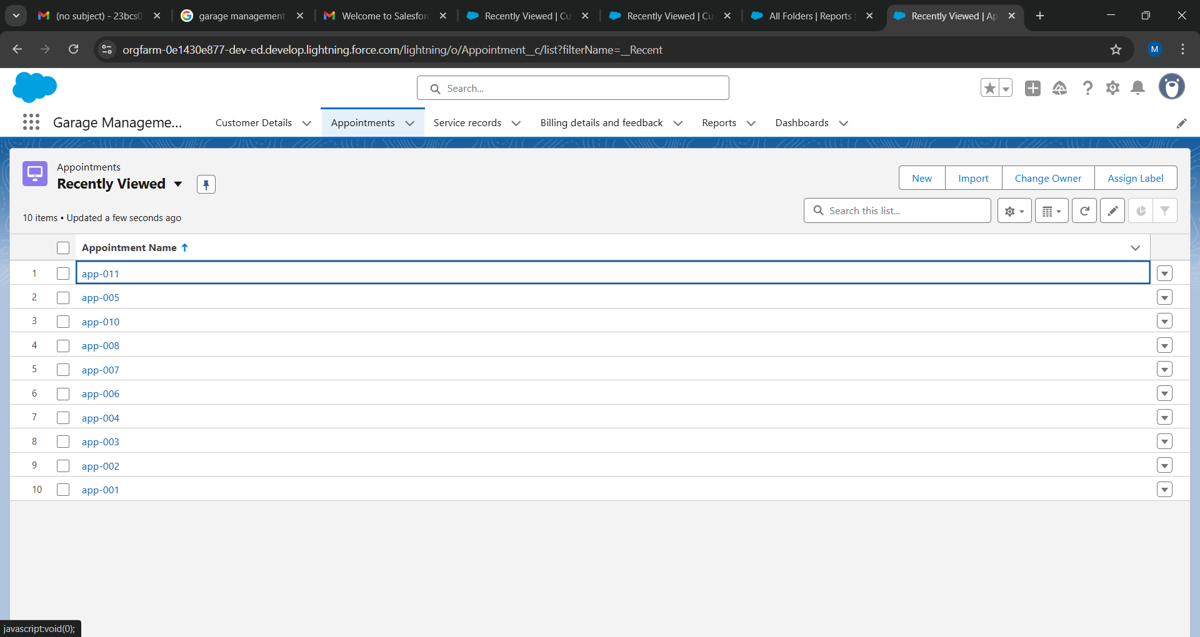

**4.3 Logging Service Records**

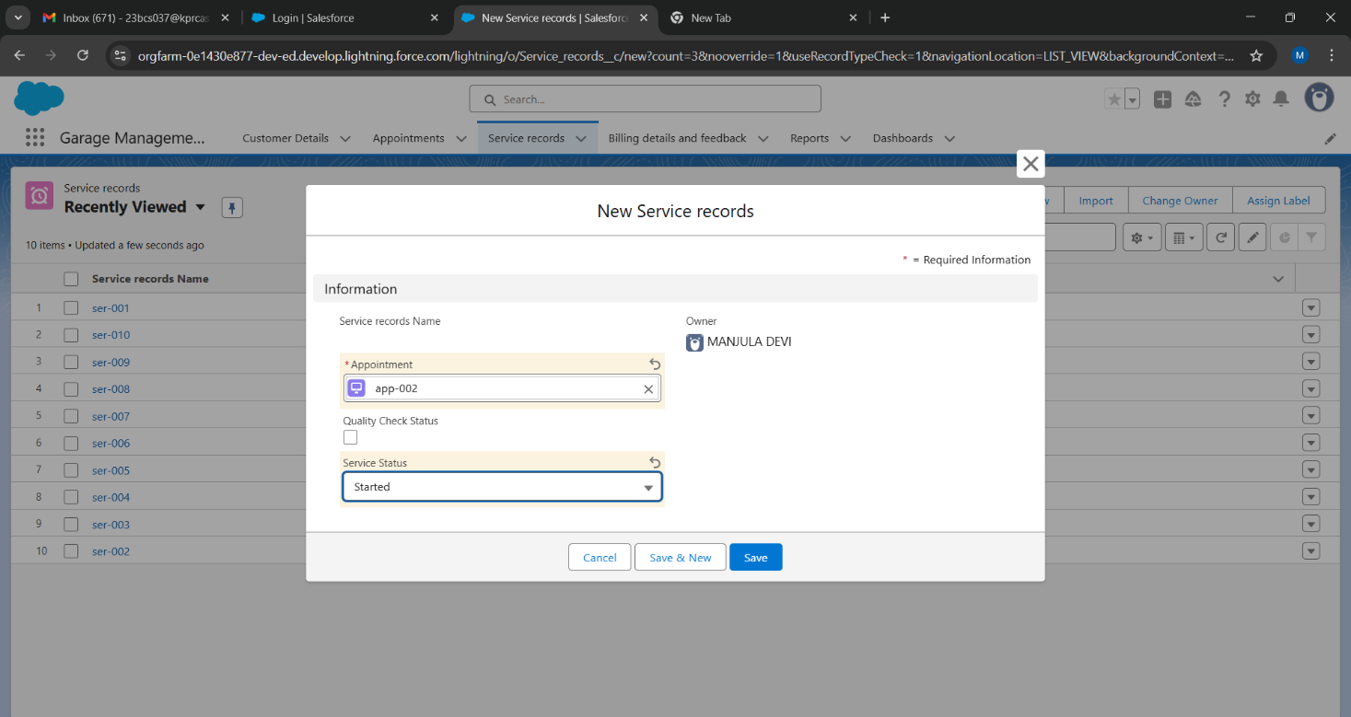

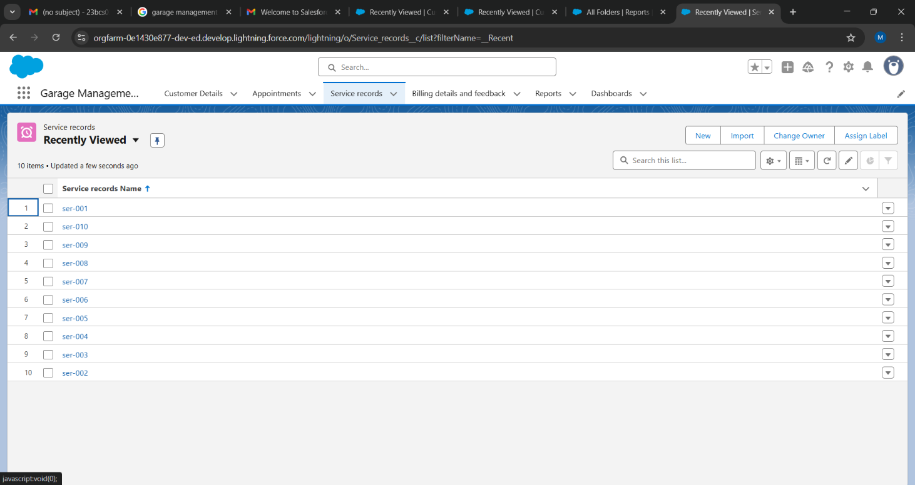

**4.4 Processing Billing and Feedback**

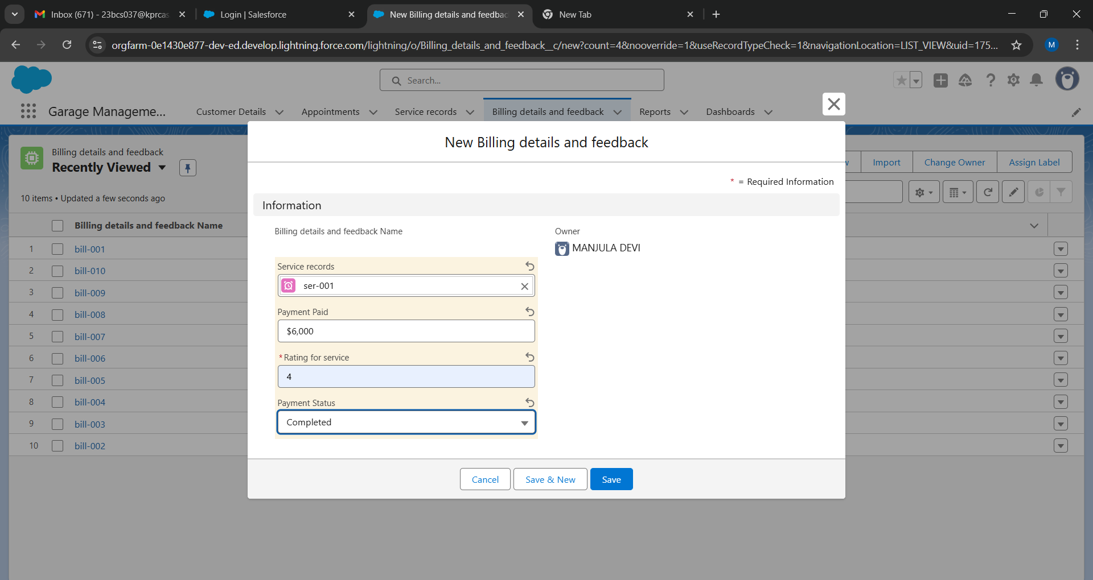

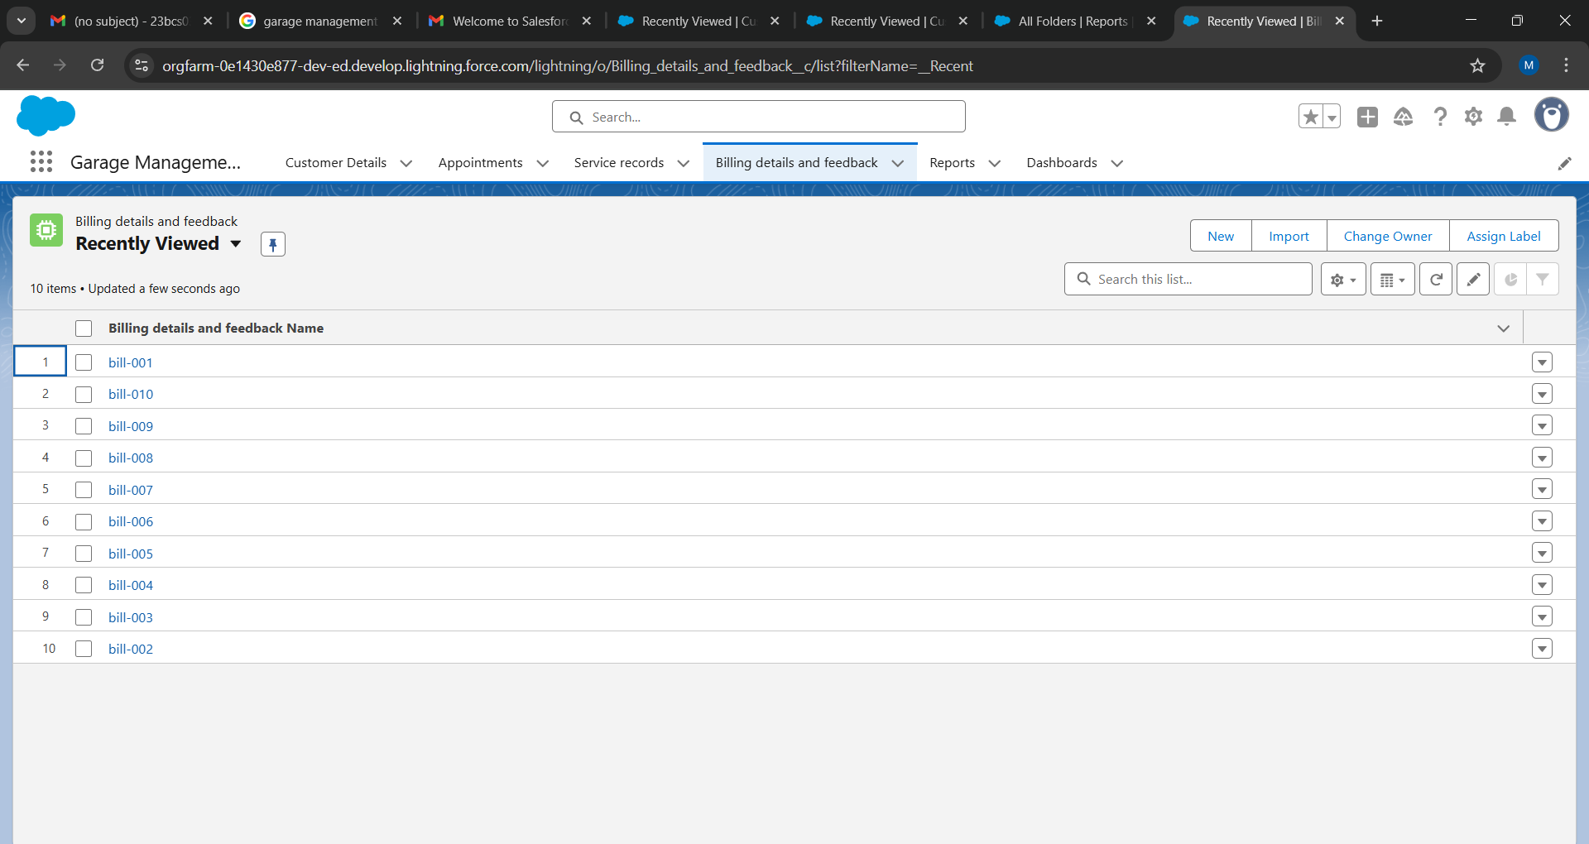

* 1. **Analyzing Data with Reports and Dashboards**

1.**Reports**

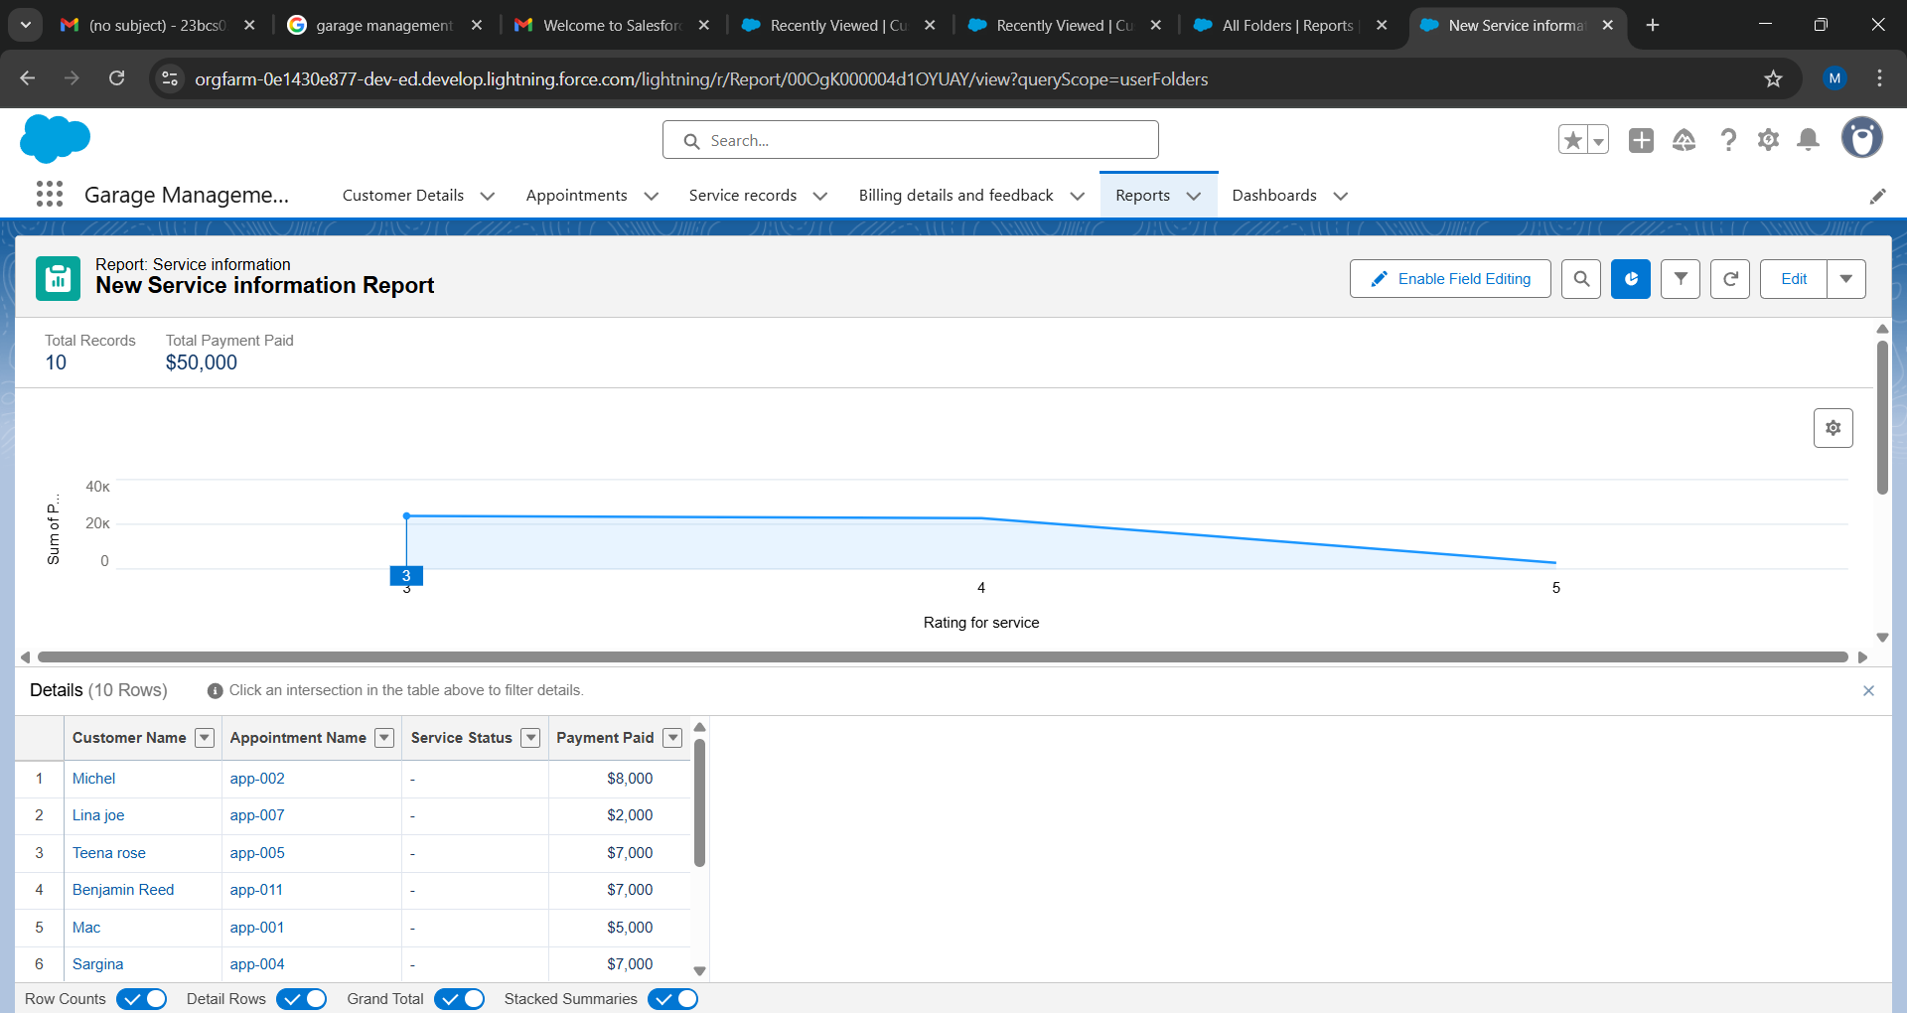

**2.Dashboards**

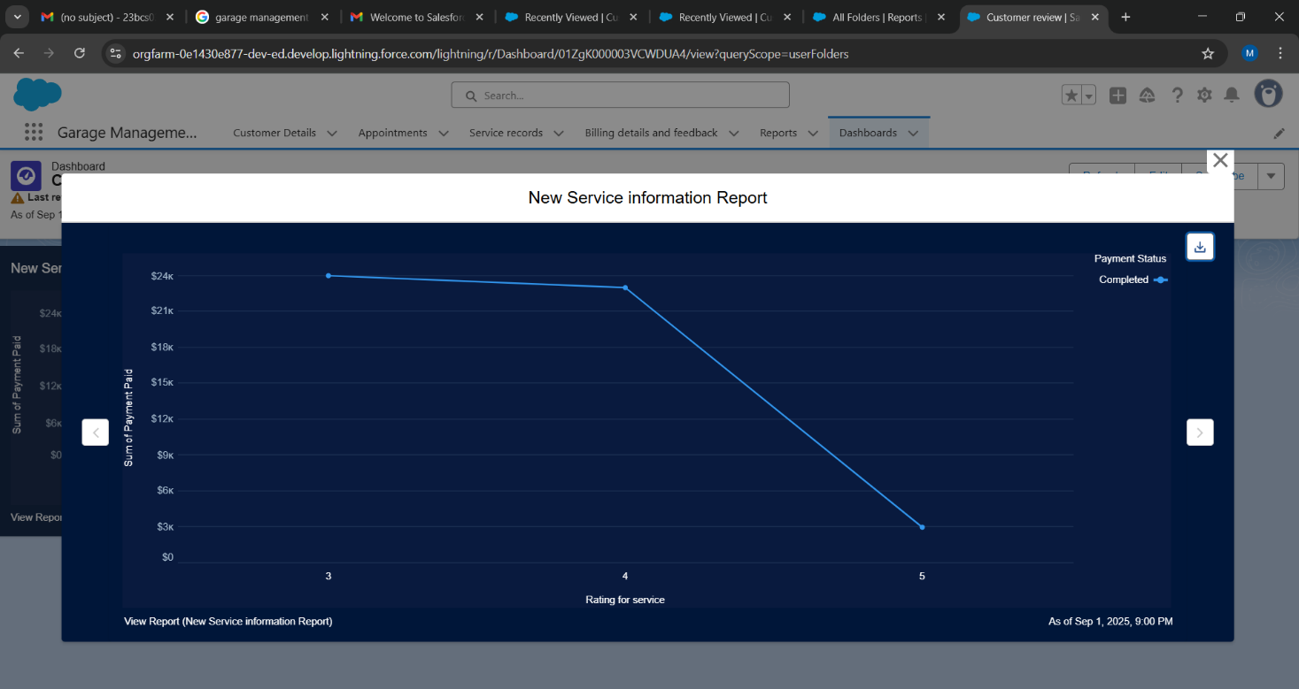

**5. Advantages and Disadvantages**

**Advantages**

1. **Centralized Data Management** – Consolidates customer, vehicle, appointment, service, and billing data in a single system, eliminating duplication and errors.
2. **Improved Efficiency** – Automation of appointment scheduling, billing, and feedback reduces manual work and streamlines daily operations.
3. **Enhanced Customer Experience** – Service history tracking and feedback collection help deliver personalized and high-quality customer service.
4. **Real-Time Insights** – Interactive reports and dashboards provide managers with real-time visibility into performance and financial metrics.
5. **Scalability** – Built on Salesforce, the system can easily expand to include new features like inventory management, supplier integration, and customer self-service portals.
6. **Data Security and Role-Based Access** – Salesforce’s role hierarchy, profiles, and sharing rules ensure sensitive information is secure and accessible only to authorized users.
7. **Reduced Errors** – Validation rules and duplicate management maintain data integrity and minimize mistakes in entries.
8. **Cloud-Based Flexibility** – Accessible from anywhere, supporting remote work and multi-branch garage operations.

**Disadvantages**

1. **High Initial Setup Complexity** – Requires careful configuration of Salesforce objects, rules, and automation, which may be challenging for non-technical users.
2. **Cost Factor** – Although the Developer Edition is free, scaling to enterprise Salesforce licenses may be expensive for small garages.
3. **Training Requirements** – Staff may need significant training to adapt to the Salesforce interface and features.
4. **Customization Limitations** – While highly flexible, some very specific business processes might require advanced Apex coding, increasing development complexity.
5. **Dependency on Internet** – Being a cloud-based solution, it requires reliable internet connectivity for uninterrupted operations.
6. **Maintenance Overhead** – Continuous updates, testing of automation, and monitoring of triggers/flows are required to avoid errors and downtime.

**6. Conclusion**

The Garage Management System successfully demonstrates the power of the Salesforce platform to build a tailored, robust, and scalable business application without the need for traditional infrastructure. By leveraging both declarative (clicks-not-code) and programmatic tools, the system delivers core functionalities essential for modern auto repair shop management—customer relationship management (CRM), scheduling, service tracking, billing, and analytics.

This project serves as a foundational model that can be extended with additional features such as inventory management for parts, integration with accounting software, SMS notifications for appointment reminders, and a customer portal for self-service. The system provides a significant competitive advantage by enhancing operational efficiency, improving customer satisfaction through organized service, and enabling data-driven strategic decisions for business growth.

**7.Appendix**

● Source Code: Provided in Apex Classes and Triggers

Apex class

**AmountDistributionHandler.apxc:**

public class AmountDistributionHandler {

public static void amountDist(list<Appointment__c> listApp){

list<Service_records__c> serList = new list <Service_records__c>();

for(Appointment__c app : listApp){

if(app.Maintenance_service__c == true && app.Repairs__c == true && app.Replacement_Parts__c == true){

app.Service_Amount__c = 10000;

}

else if(app.Maintenance_service__c == true && app.Repairs__c == true){

app.Service_Amount__c = 5000;

}

else if(app.Maintenance_service__c == true && app.Replacement_Parts__c == true){

app.Service_Amount__c = 8000;

}

else if(app.Repairs__c == true && app.Replacement_Parts__c == true){

app.Service_Amount__c = 7000;

}

else if(app.Maintenance_service__c == true){

app.Service_Amount__c = 2000;

}

else if(app.Repairs__c == true){

app.Service_Amount__c = 3000;

}

else if(app.Replacement_Parts__c == true){

app.Service_Amount__c = 5000;

}

}

}

}

Apex Trigger

**AmountDistribution.apxt:**

trigger AmountDistribution on Appointment__c (before insert, before update) {

if(trigger.isbefore && trigger.isinsert || trigger.isupdate){

AmountDistributionHandler.amountDist(trigger.new);

}

}